**CLOUD COMPUTING LAB**



**Submitted By: Zunaira Khatoon**

**Submitted To: Engr. Muhammad Shoaib**

**Roll No: BSE-2023-074**

**Section: V-B**

***LAB 8***

**Task 1 — Create an AWS account and enable UAE (me-central-1)**

Open your browser and go to: [AWS Signup](https://signin.aws.amazon.com/signup?request_type=register)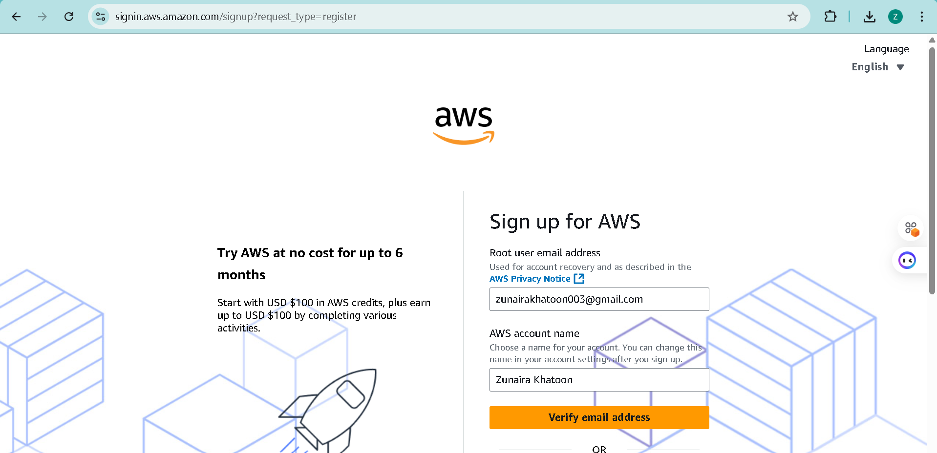

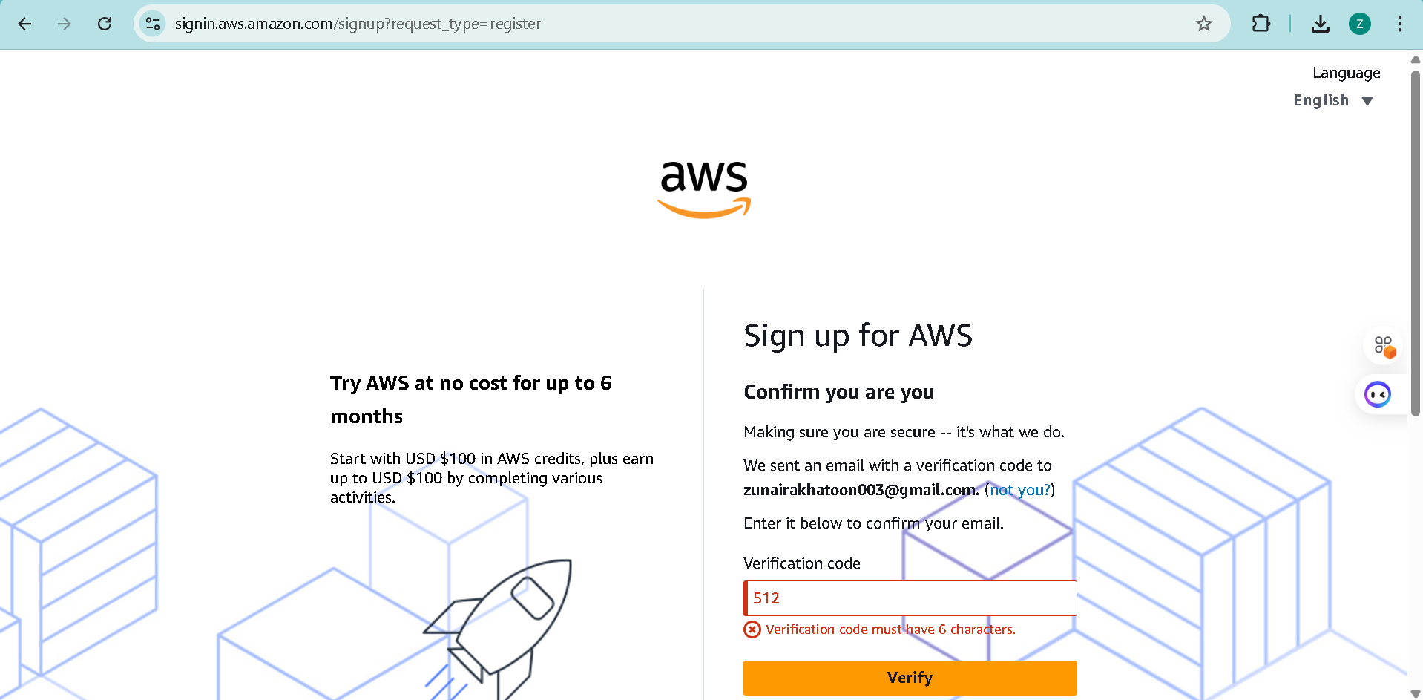

Complete registration (Account type: Personal, Plan: AWS Paid Plan), fill contact, billing (credit card) and phone details, complete verification. After successful registration capture:

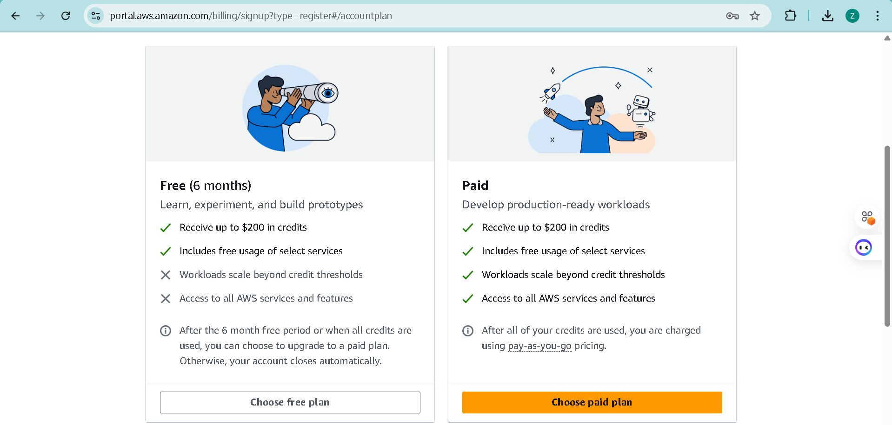

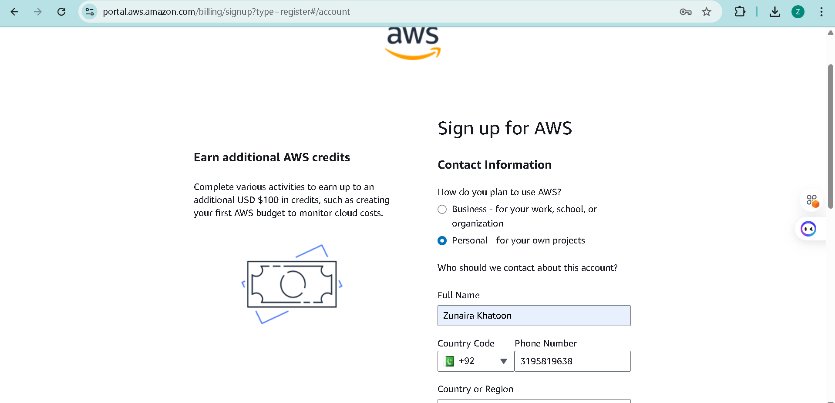

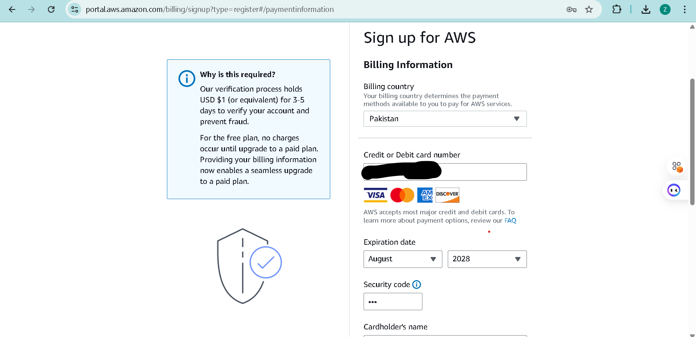

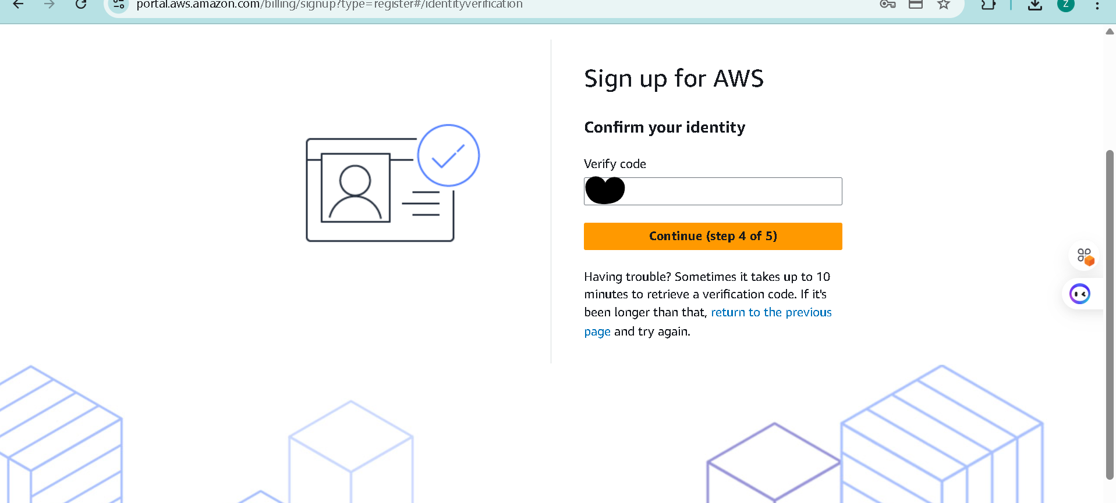

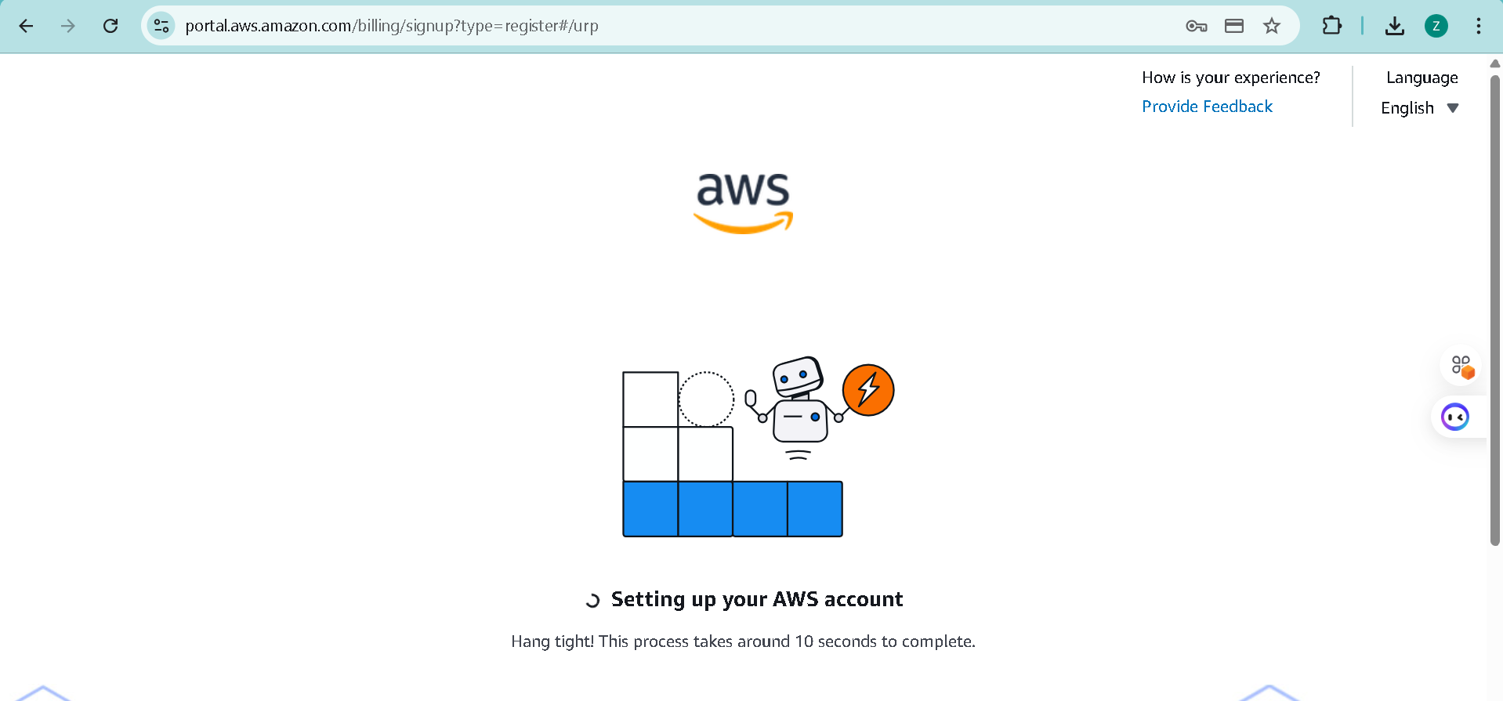

Complete registration (Account type: Personal, Plan: AWS Paid Plan), fill contact, billing (credit card) and phone details, complete verification. After successful registration capture: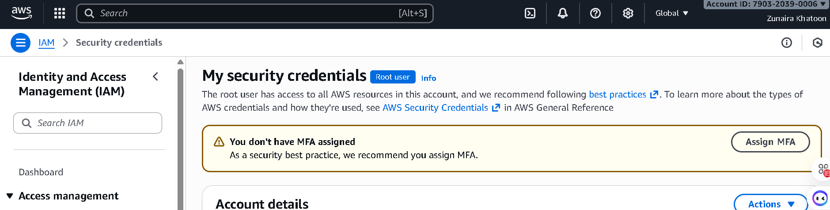

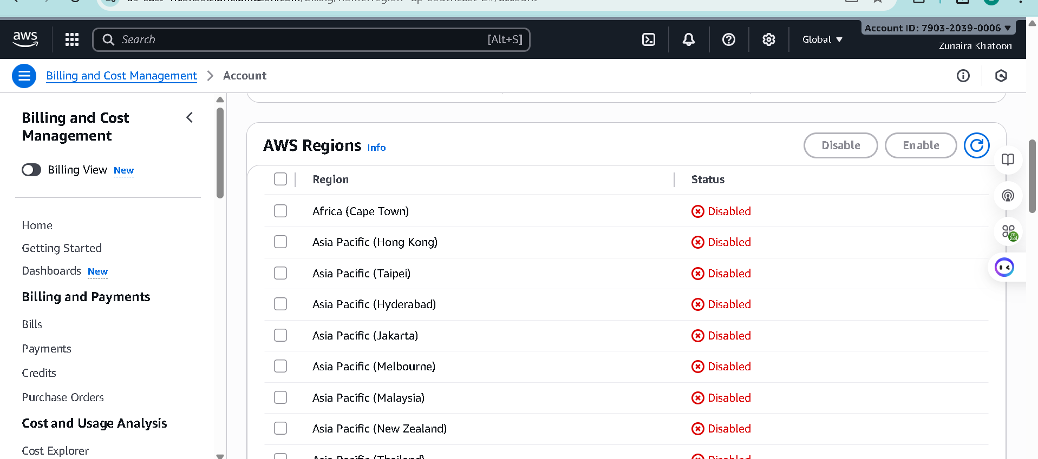

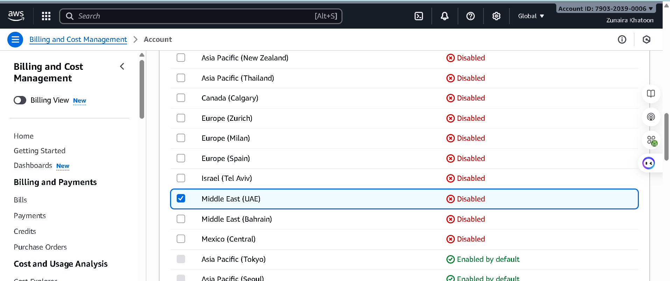

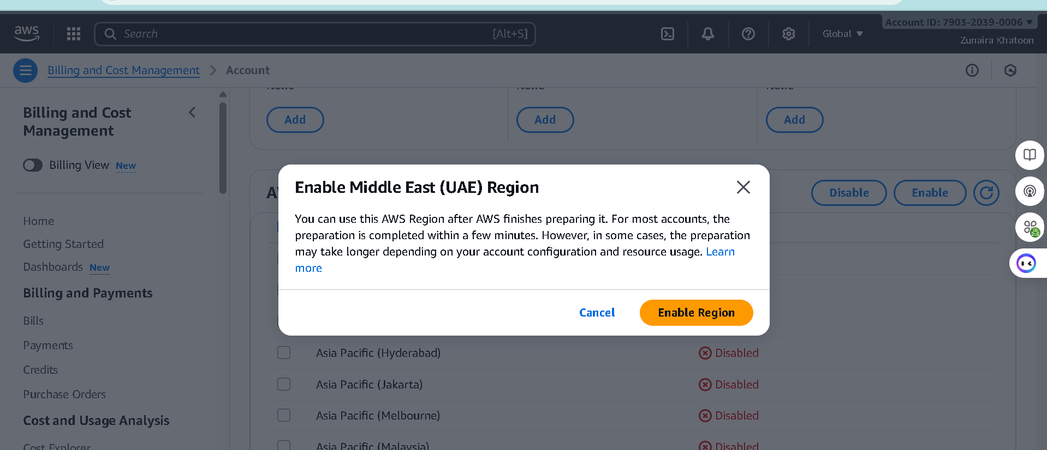

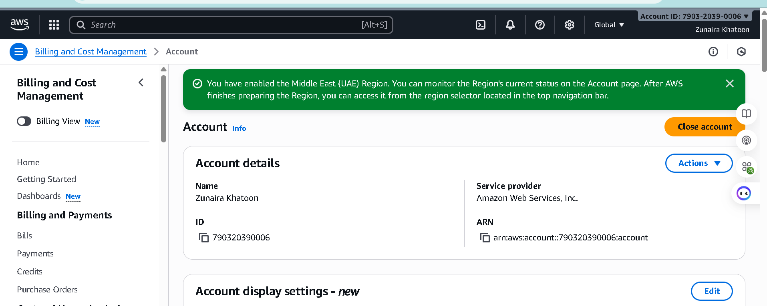

Sign in as the root user (root email).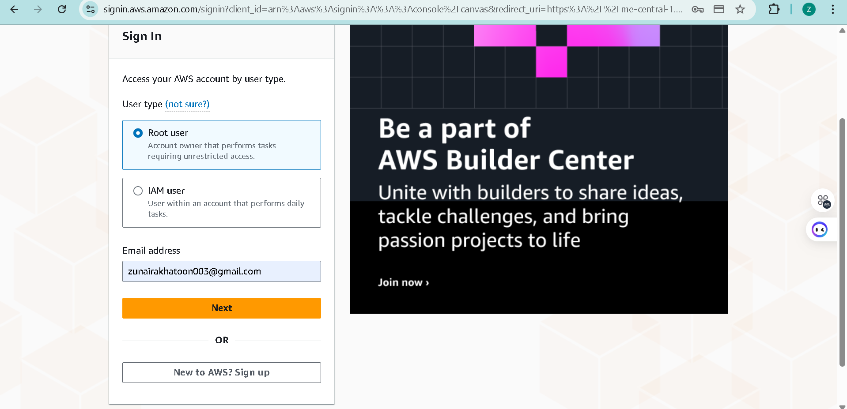

Step5: Task 1 summary screenshot (combine evidence):

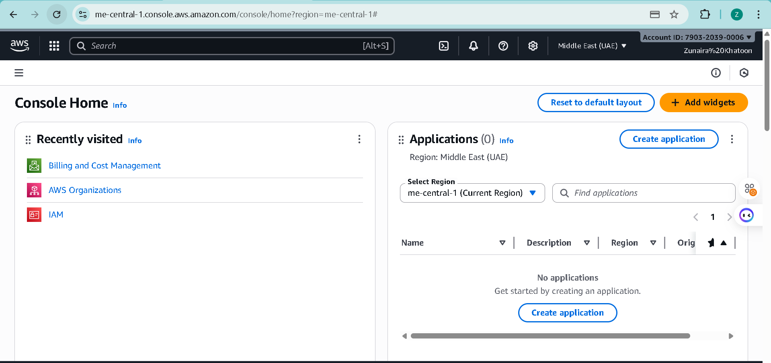

**Task 2 — Create IAM Admin and Lab8User with console access**

Open IAM via Console search (Alt+S → "IAM").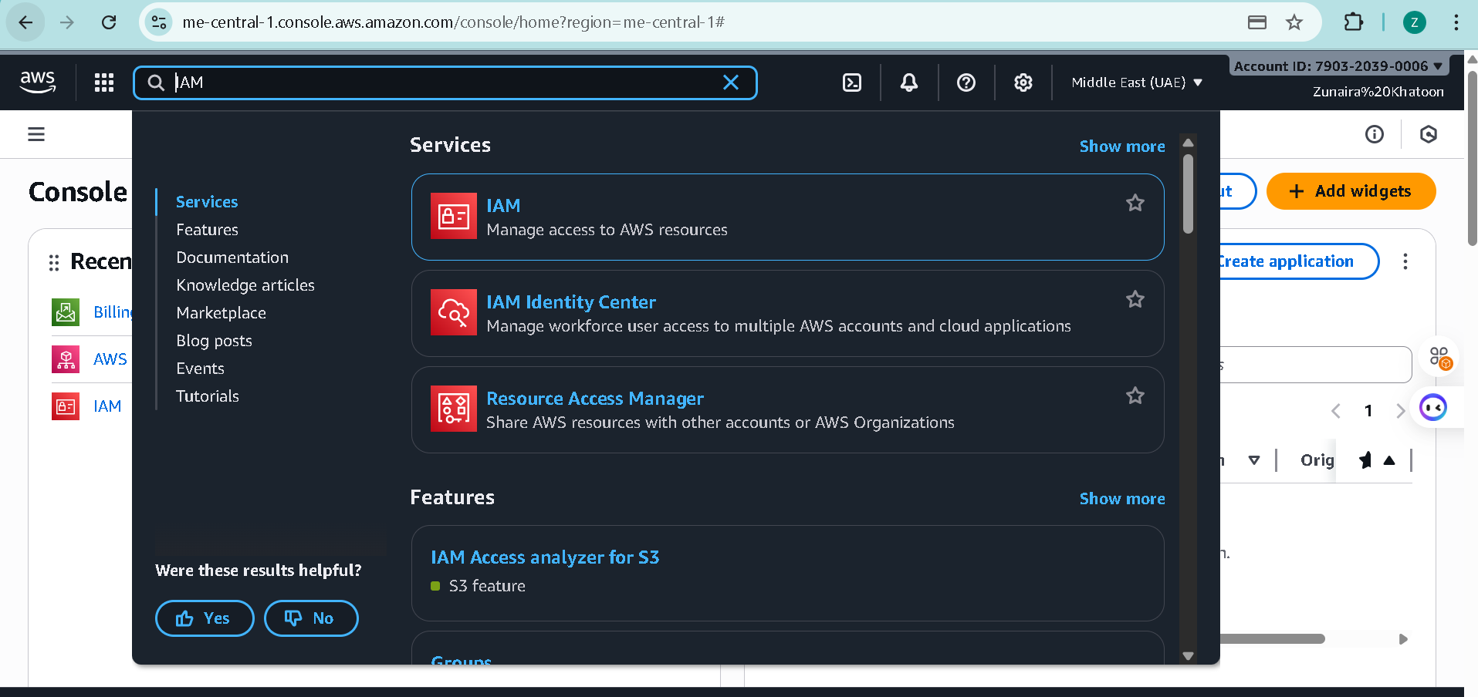

Step2: Create the Admin user: IAM → Users → Create user.

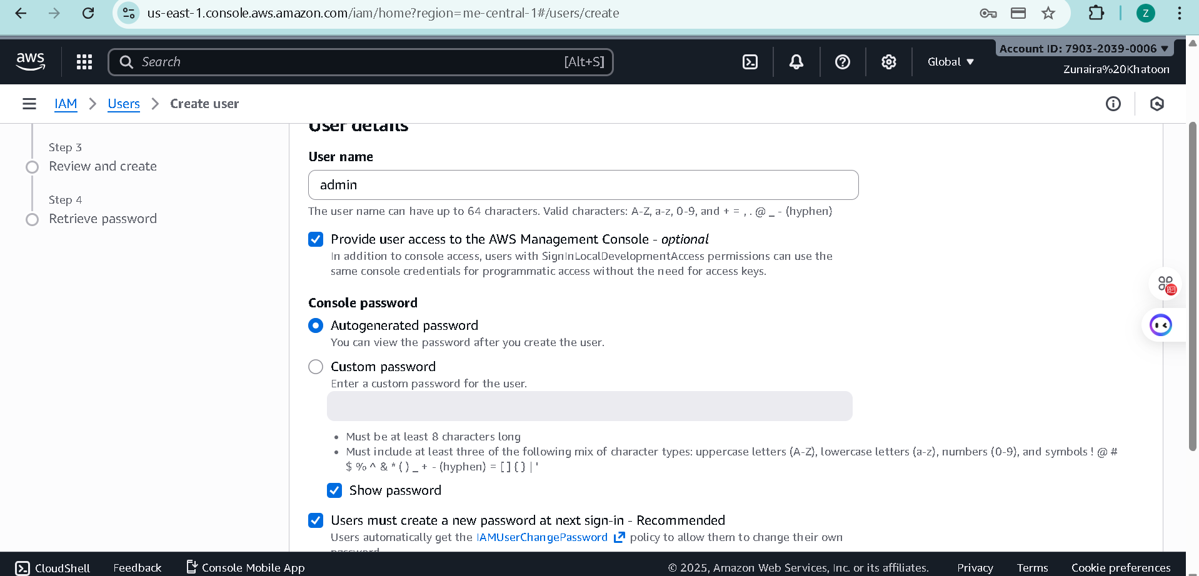

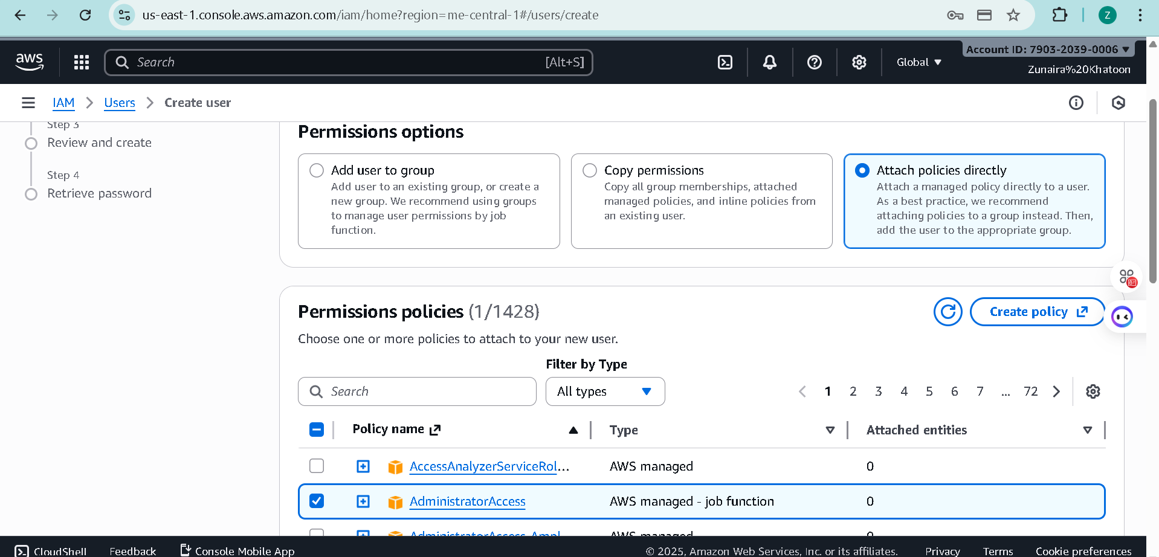

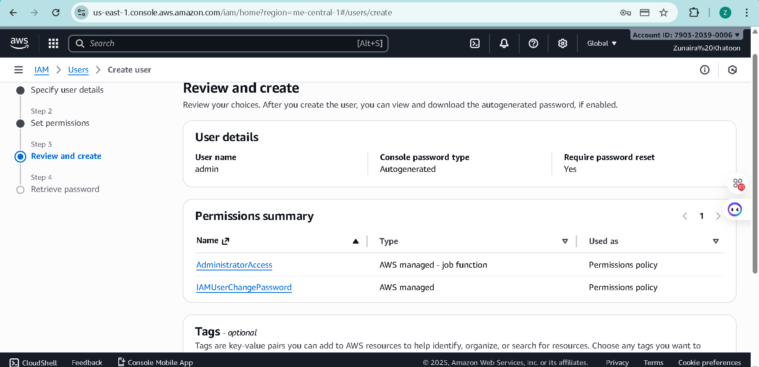

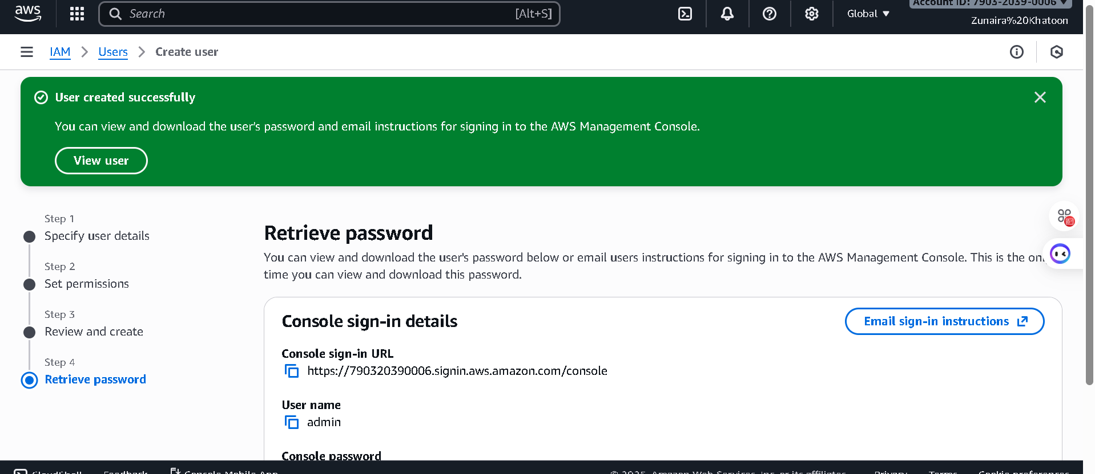

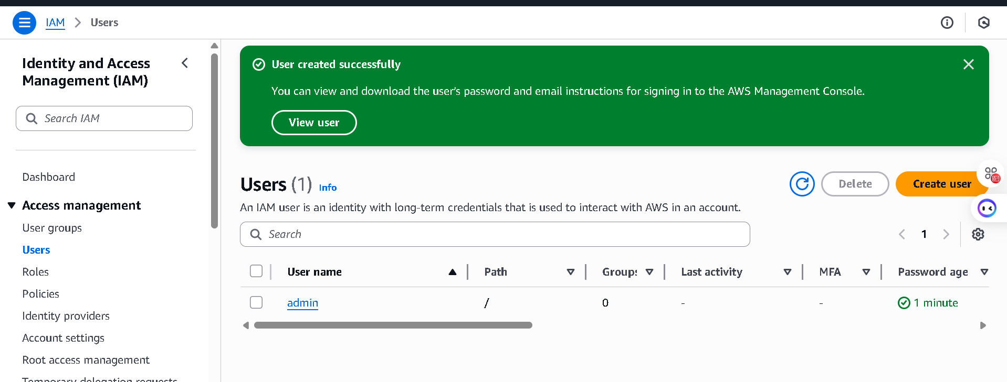

Step3: Download the Admin .csv and show its presence on your Windows host (do not display the password text):

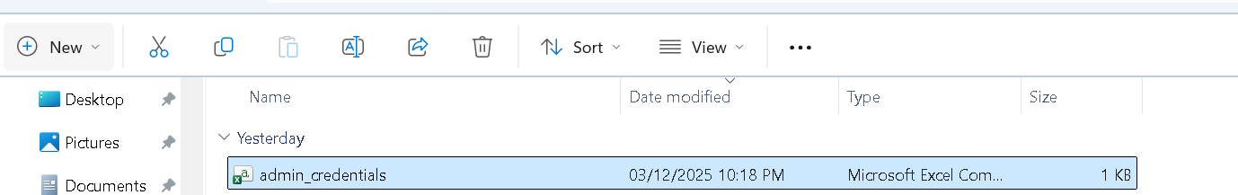

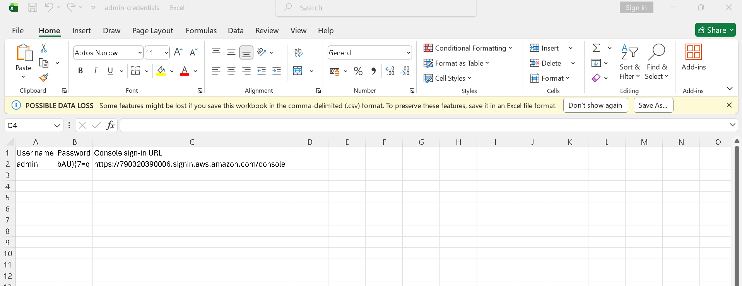

Step4: Sign out of root, then sign in using the Admin account (use the signin URL from the .csv). Capture after successful Admin login:

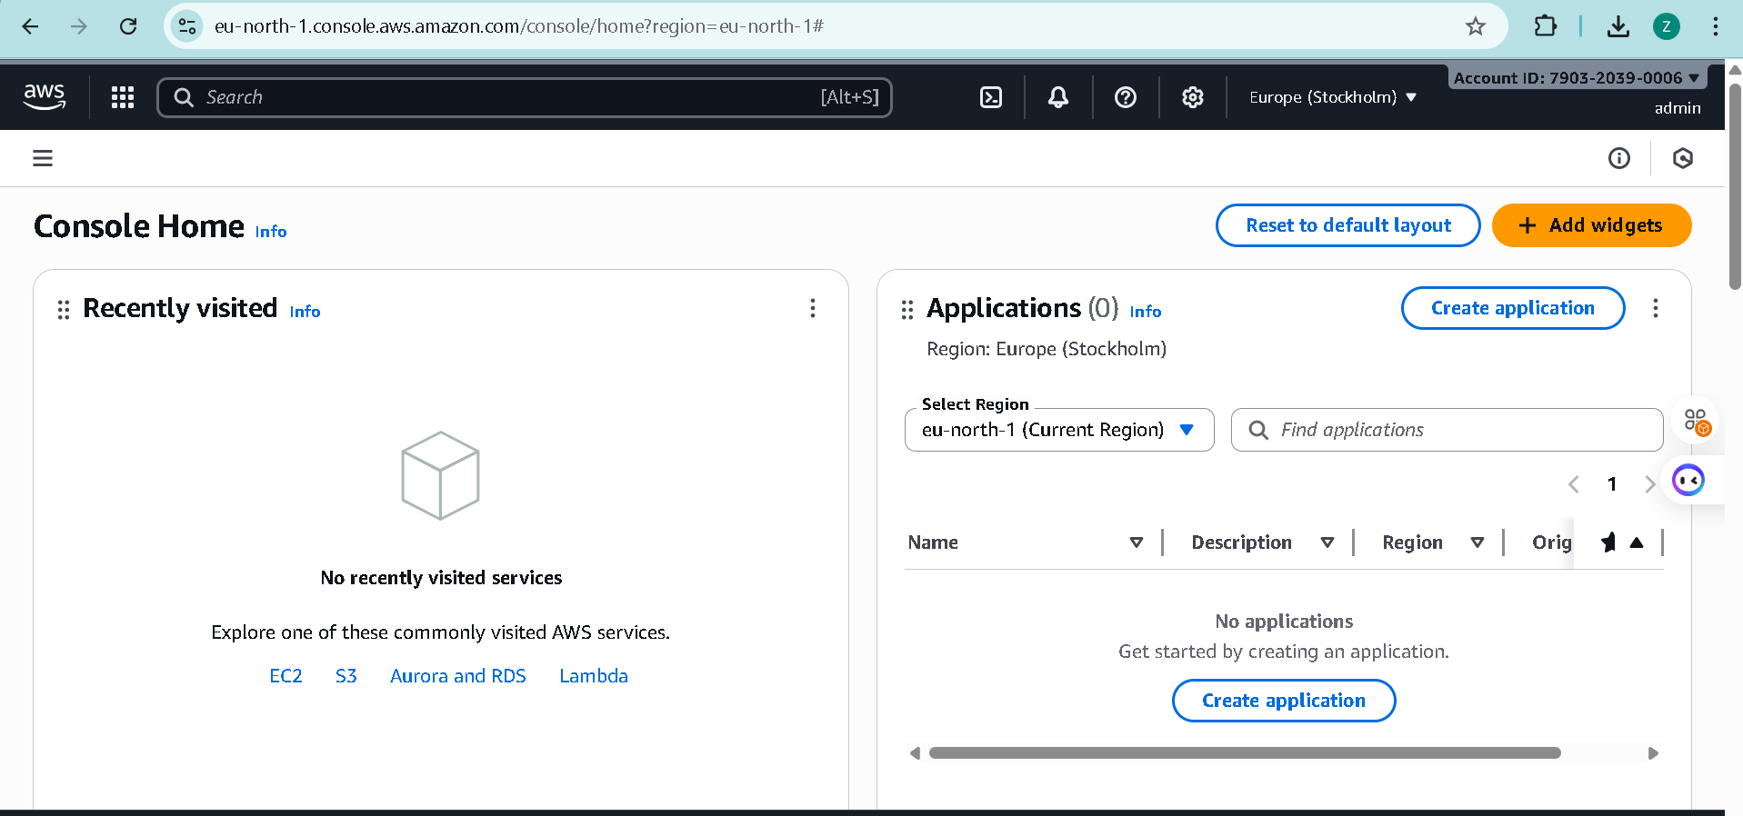

Step5: While logged in as Admin, create Lab8User:

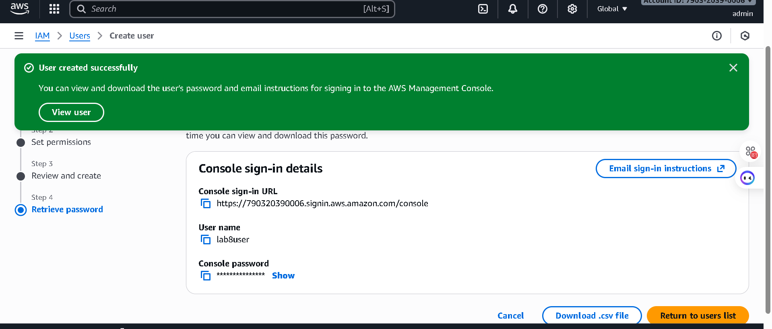

Step6: Download/save the Lab8User CSV on your Windows host (do not show password).

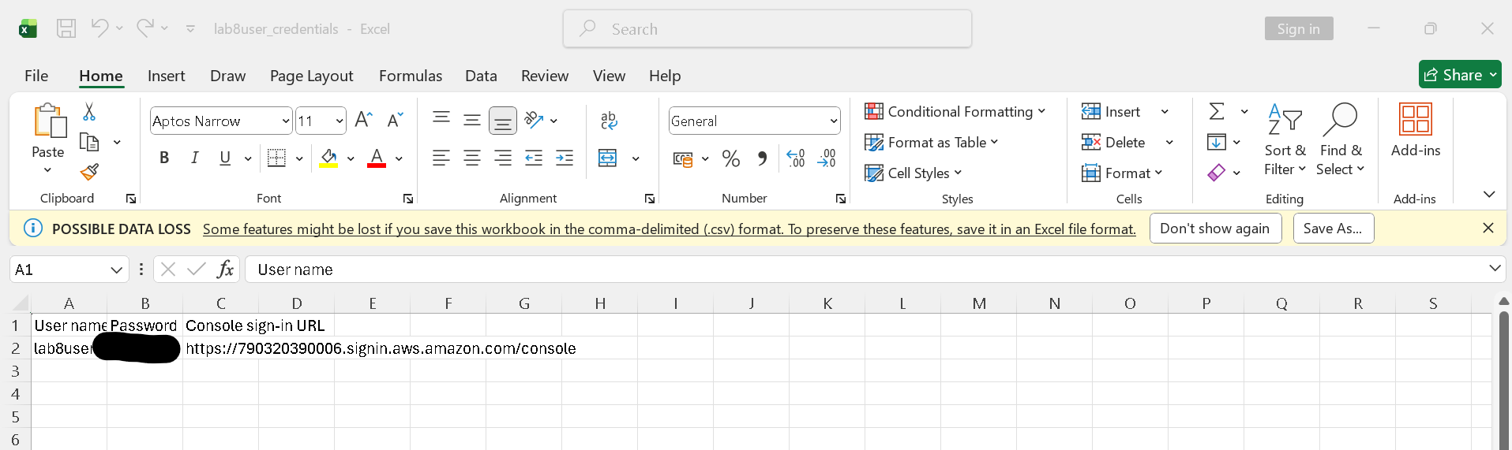

Step7: Logout Admin and login as Lab8User (use the Lab8User signin URL and credentials).

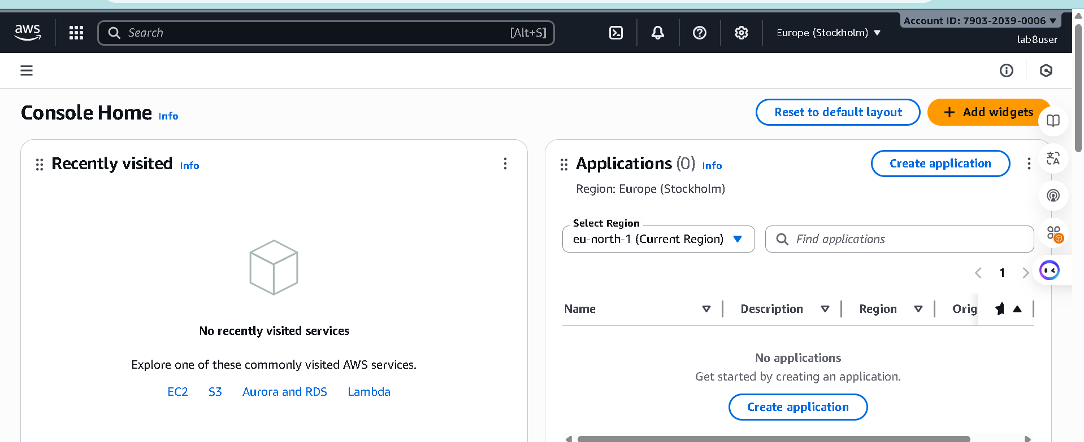

Step8: Task 2 summary (combine evidence):

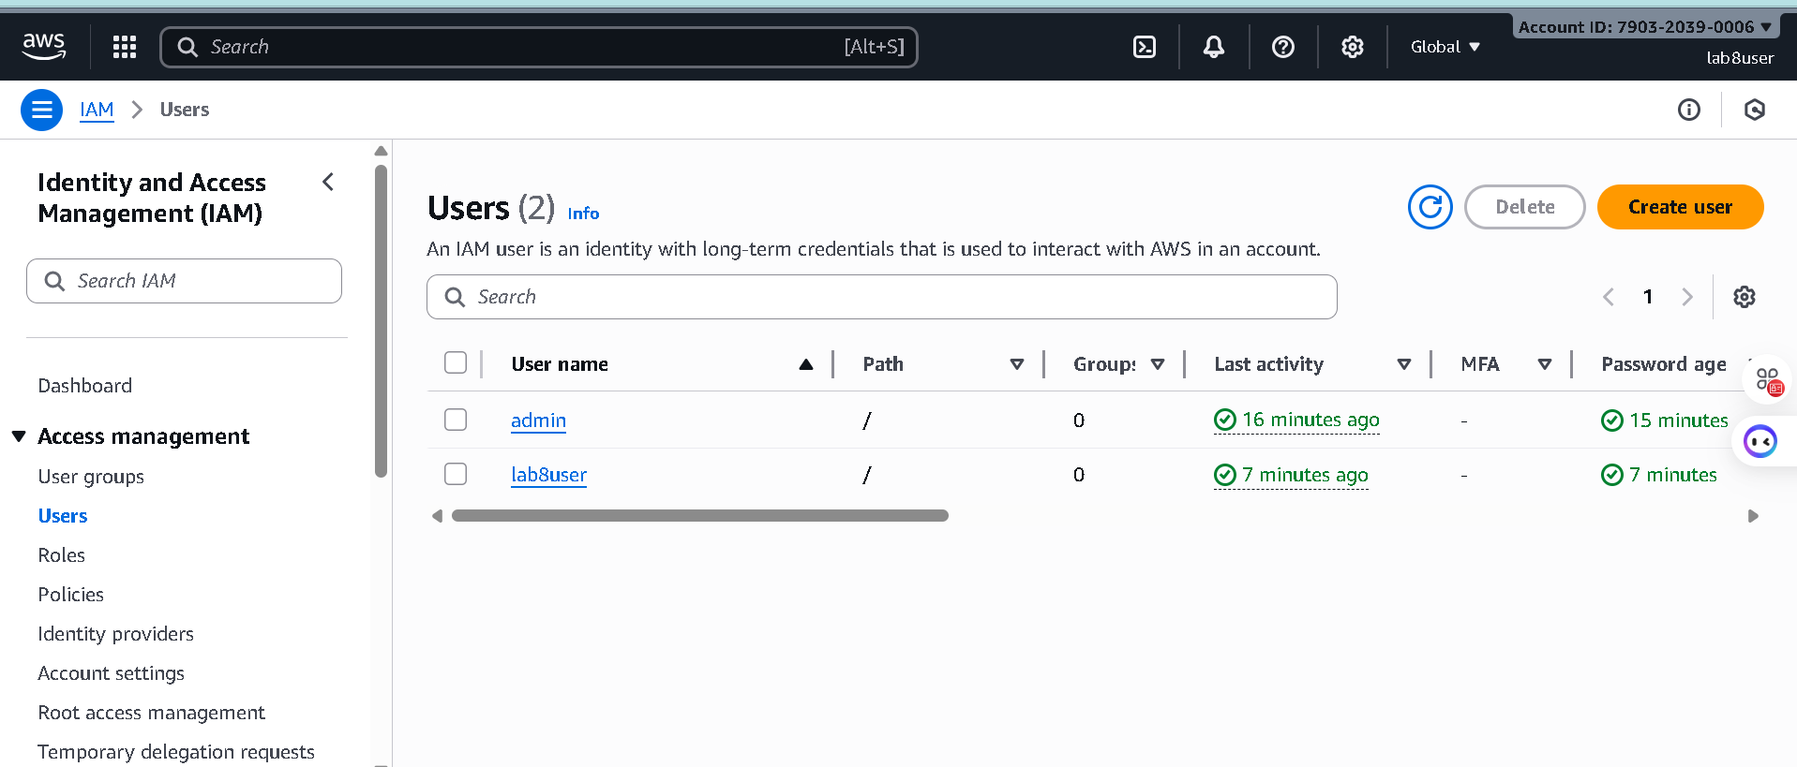

**Task 3 — Inspect VPC resources (in UAE me-central-1)**

Step1: Open VPC console (Alt+S → "VPC") while region is me-central-1.

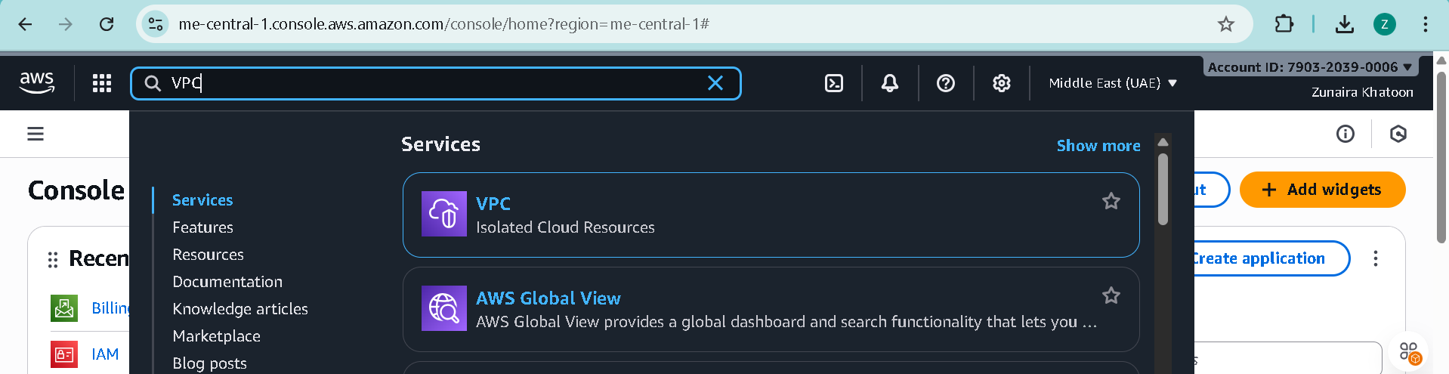

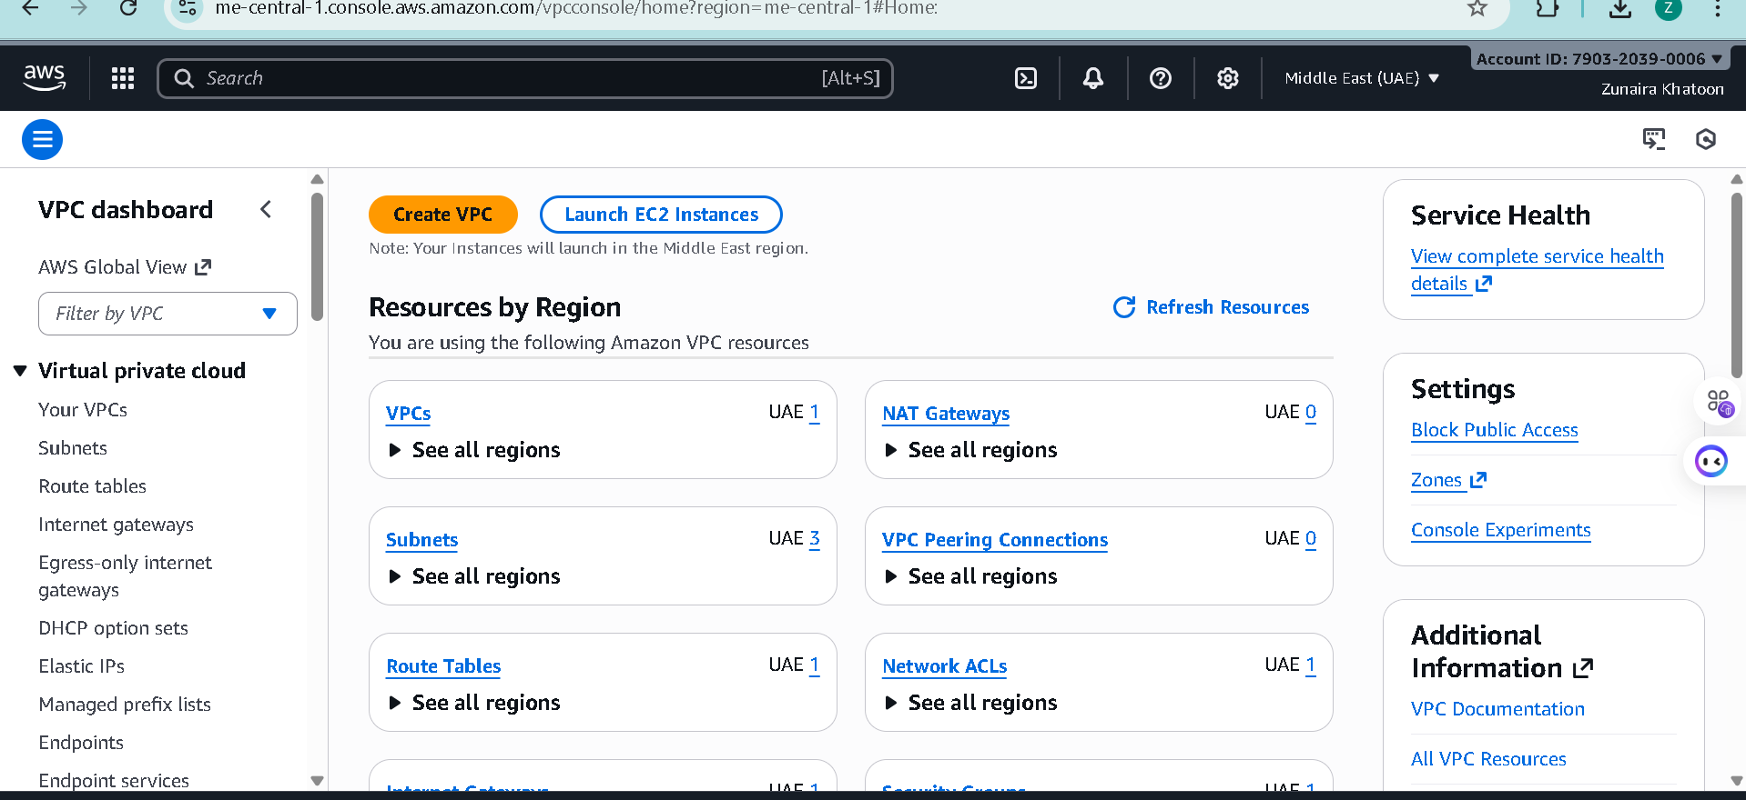

Step2: View VPCs list.

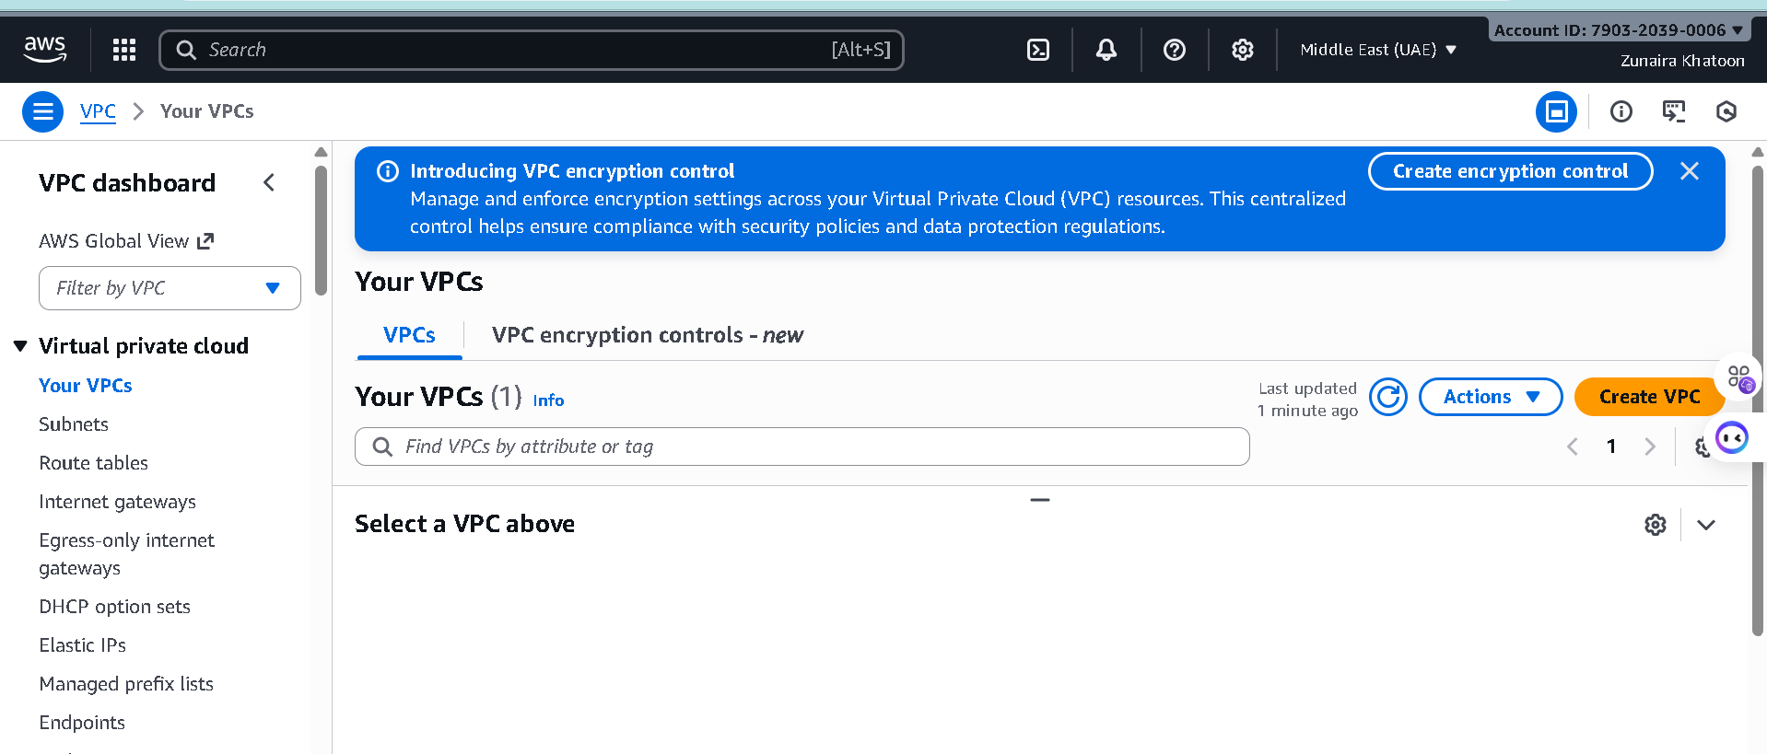

Step3: View Subnets list

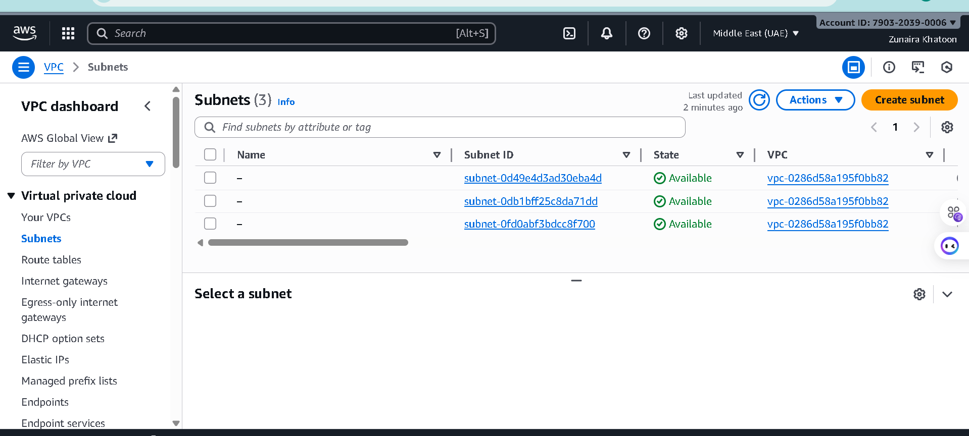

Step4: View Route Tables list

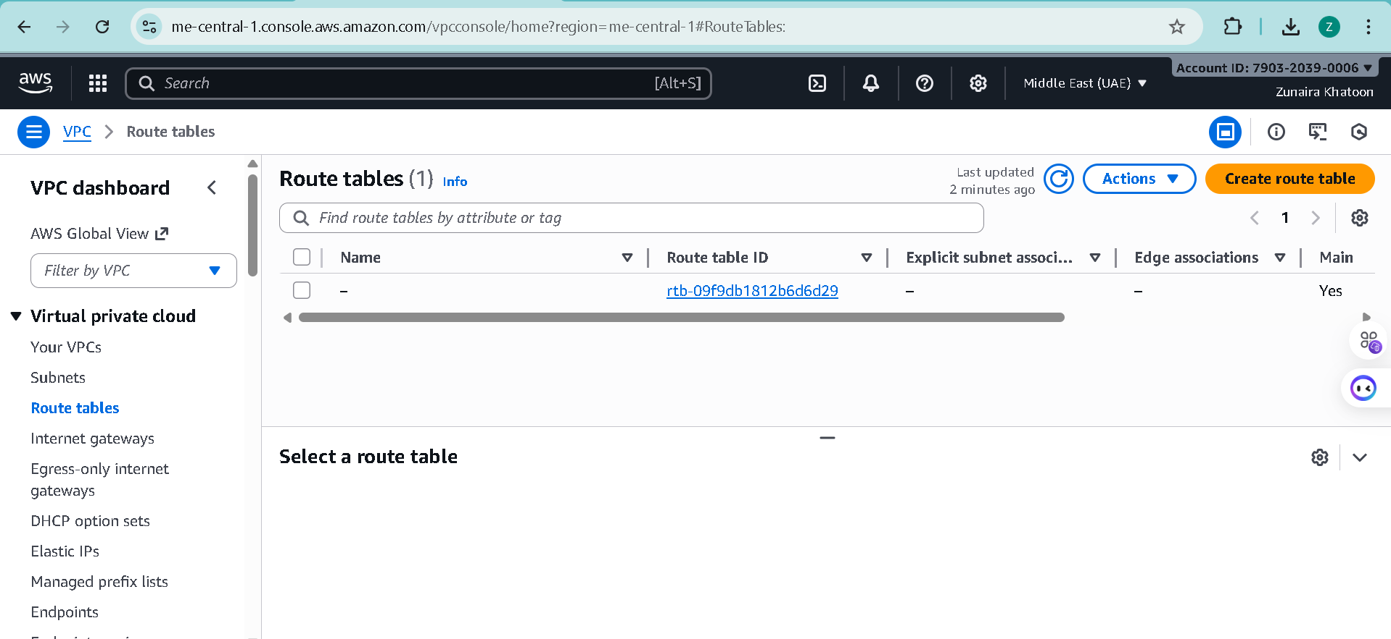

Step5: View Network ACLs list.

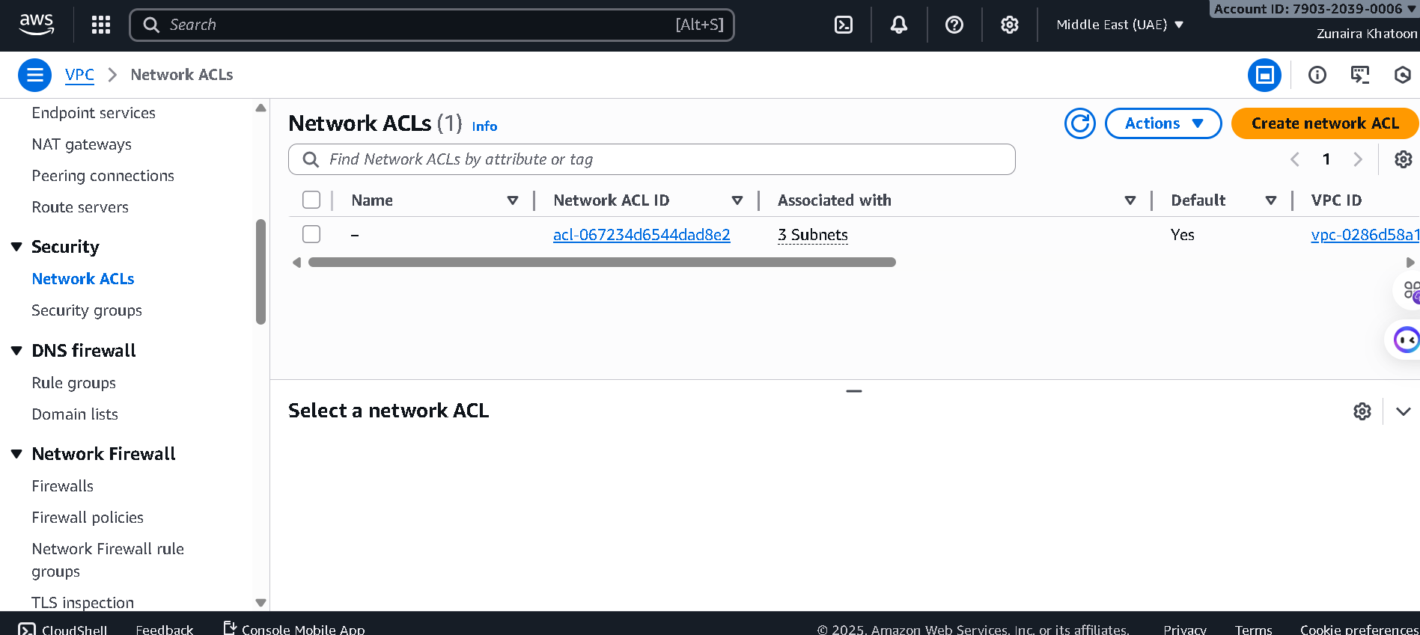

Step6: Task 3 summary (combine evidence):

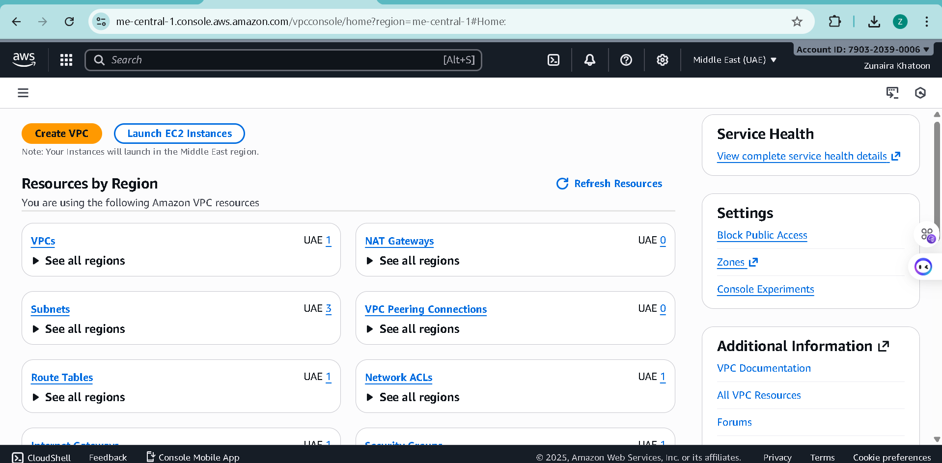

**Task 4 — Launch EC2, SSH, install Docker & Docker Compose, deploy Gitea**

Step1: Open EC2 Console (Alt+S → "EC2") (me-central-1).

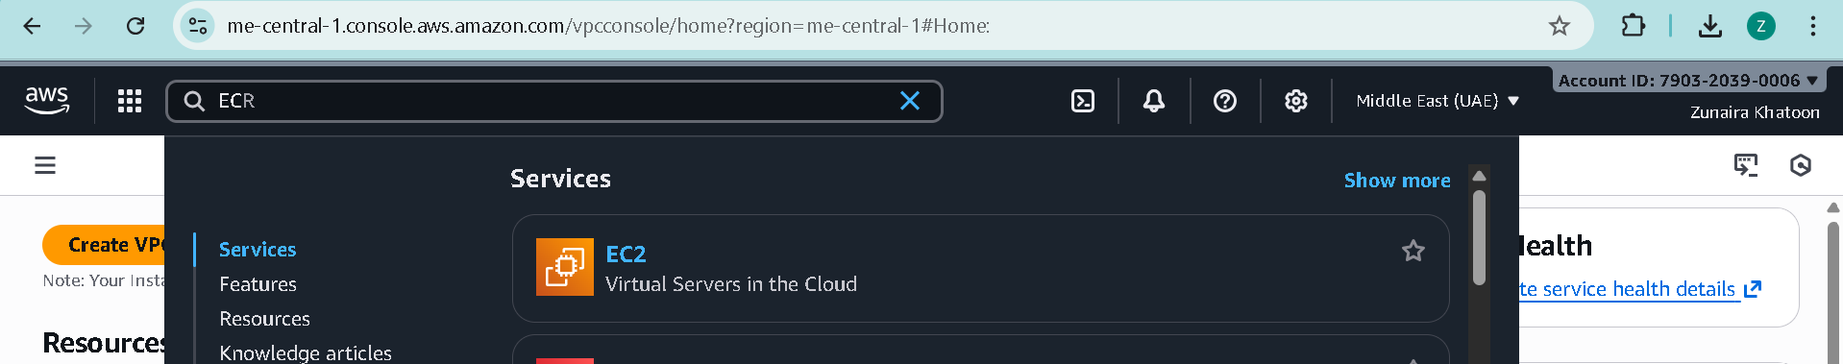

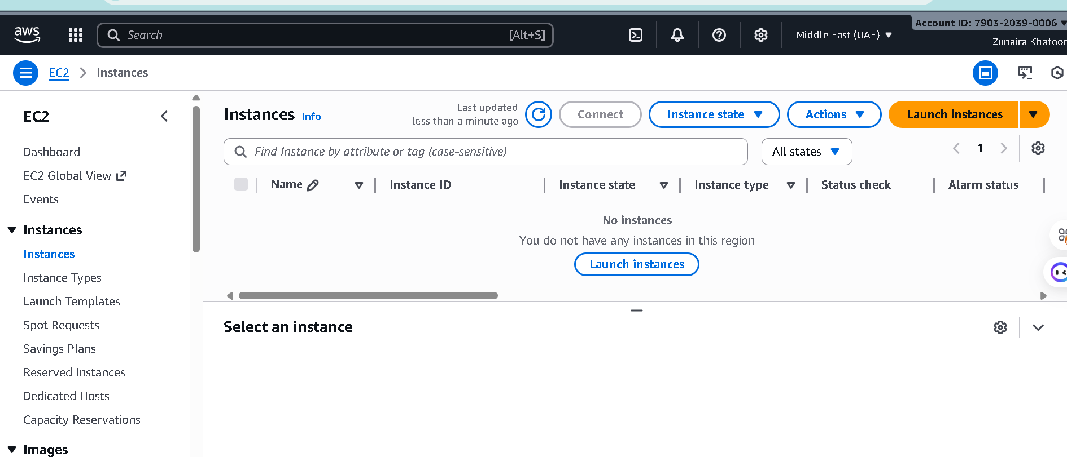

Step2: Instance Launch configuration (during review before launching).

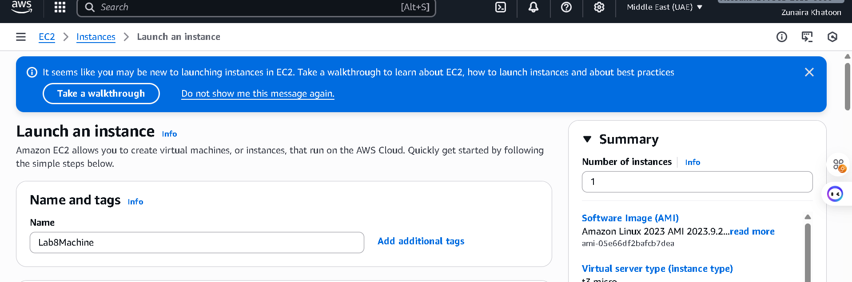

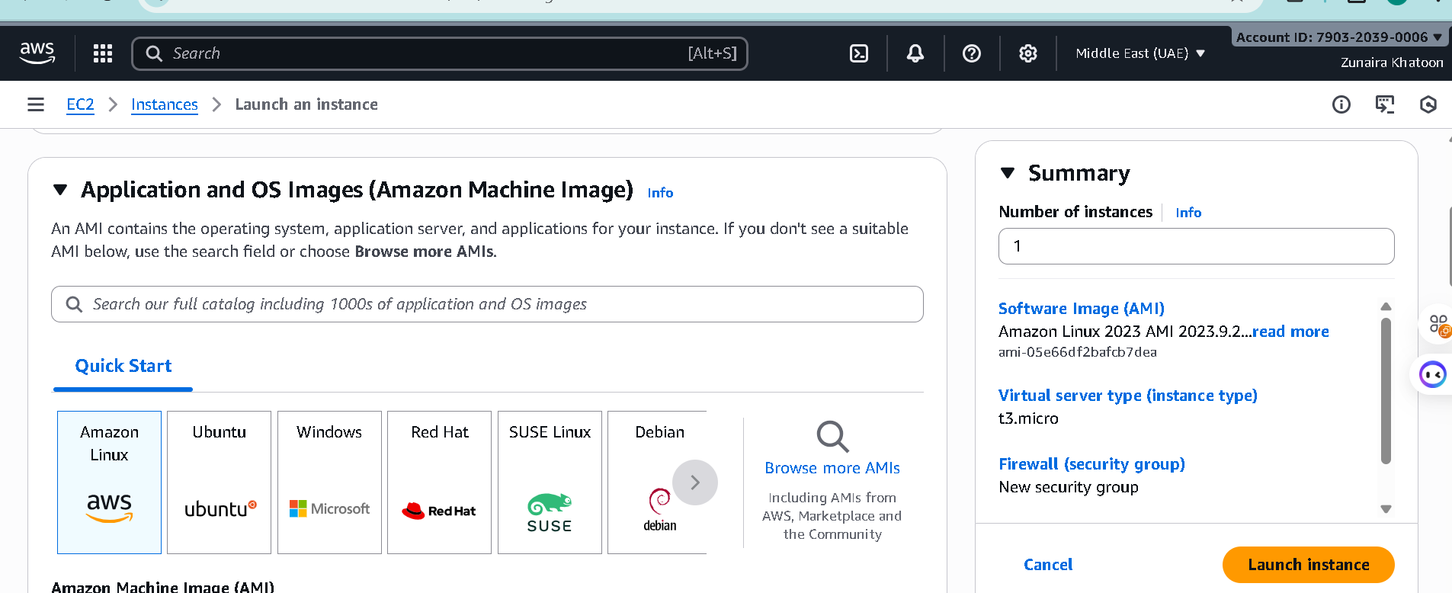

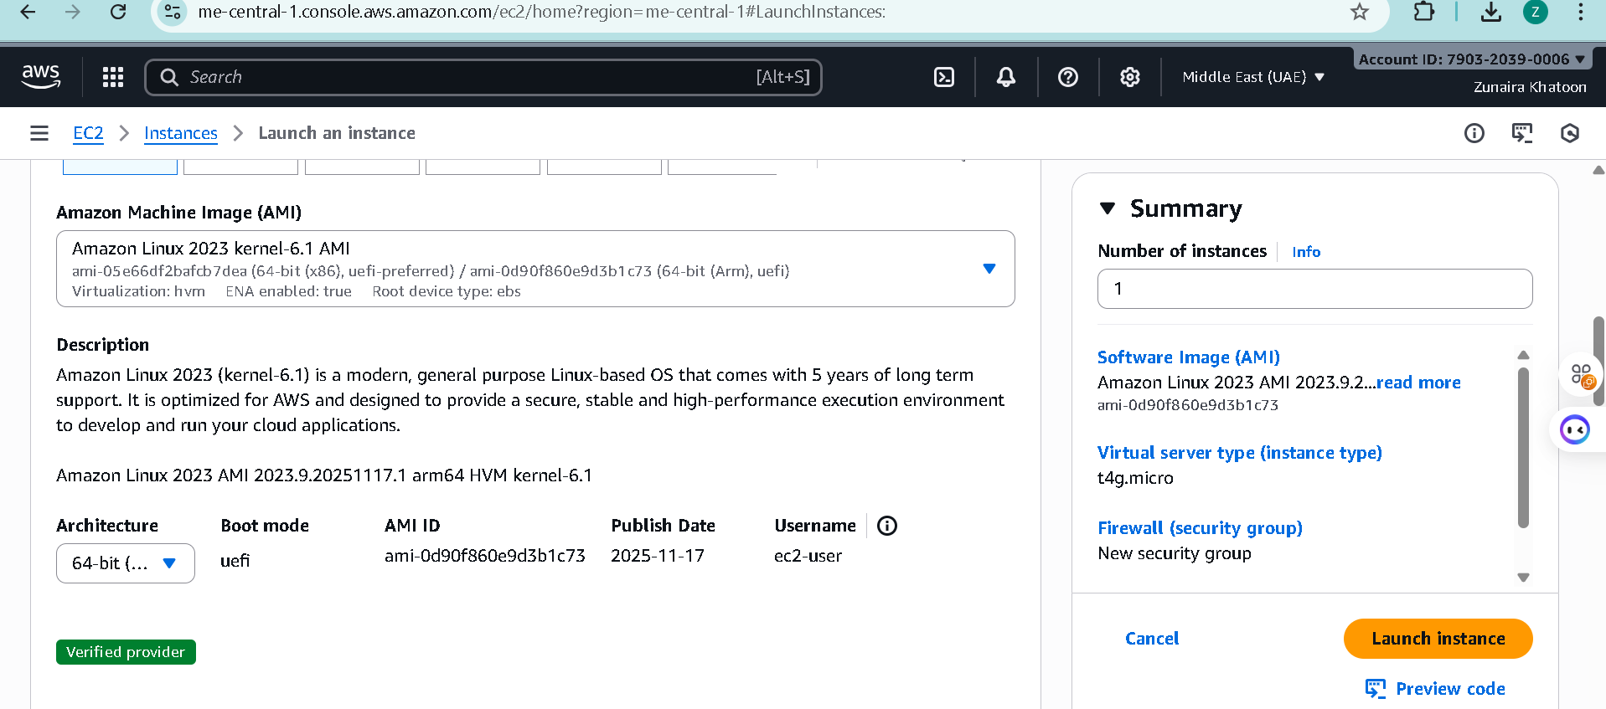

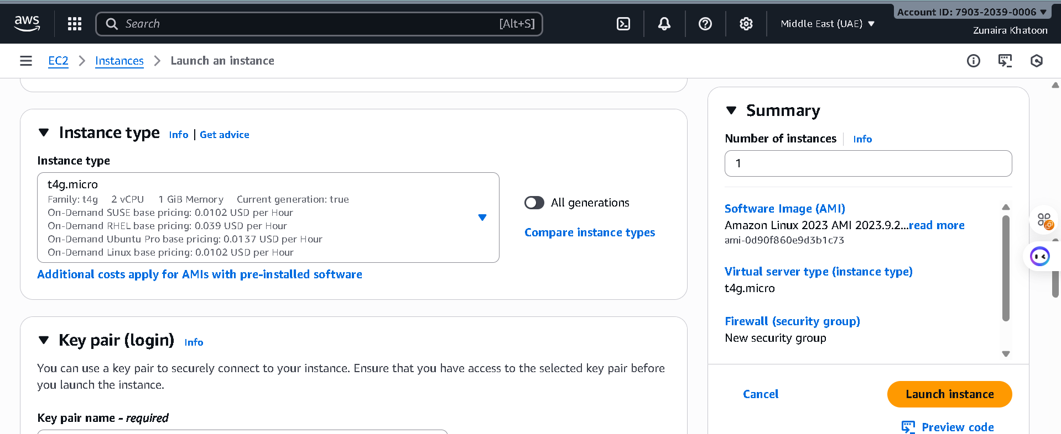

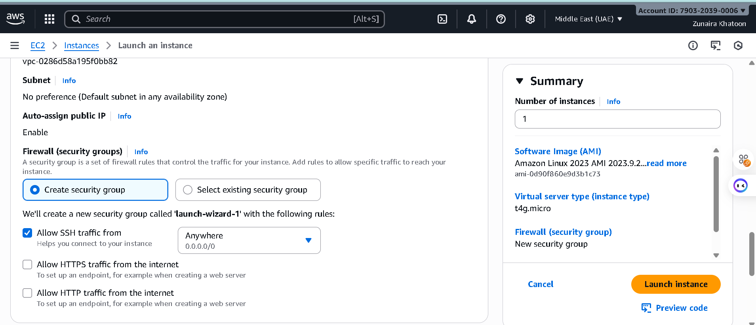

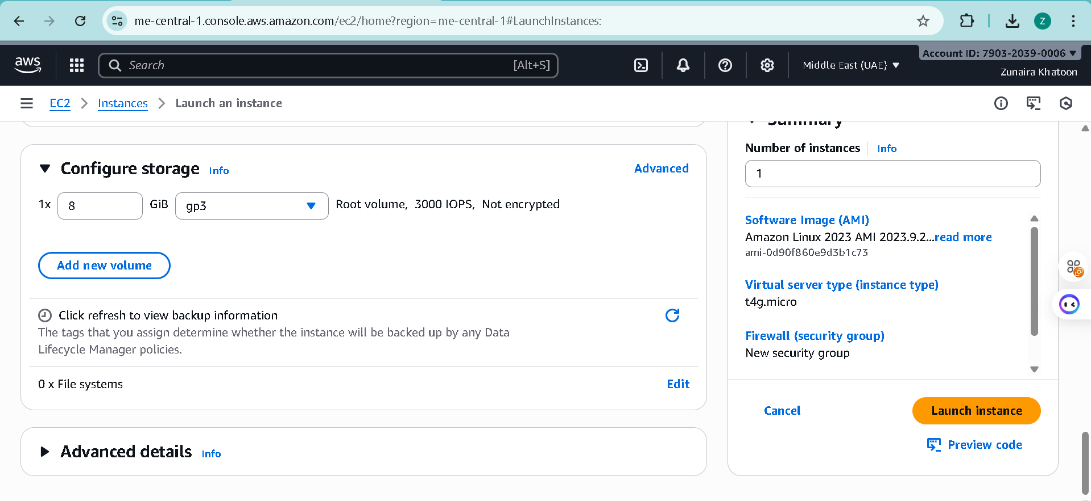

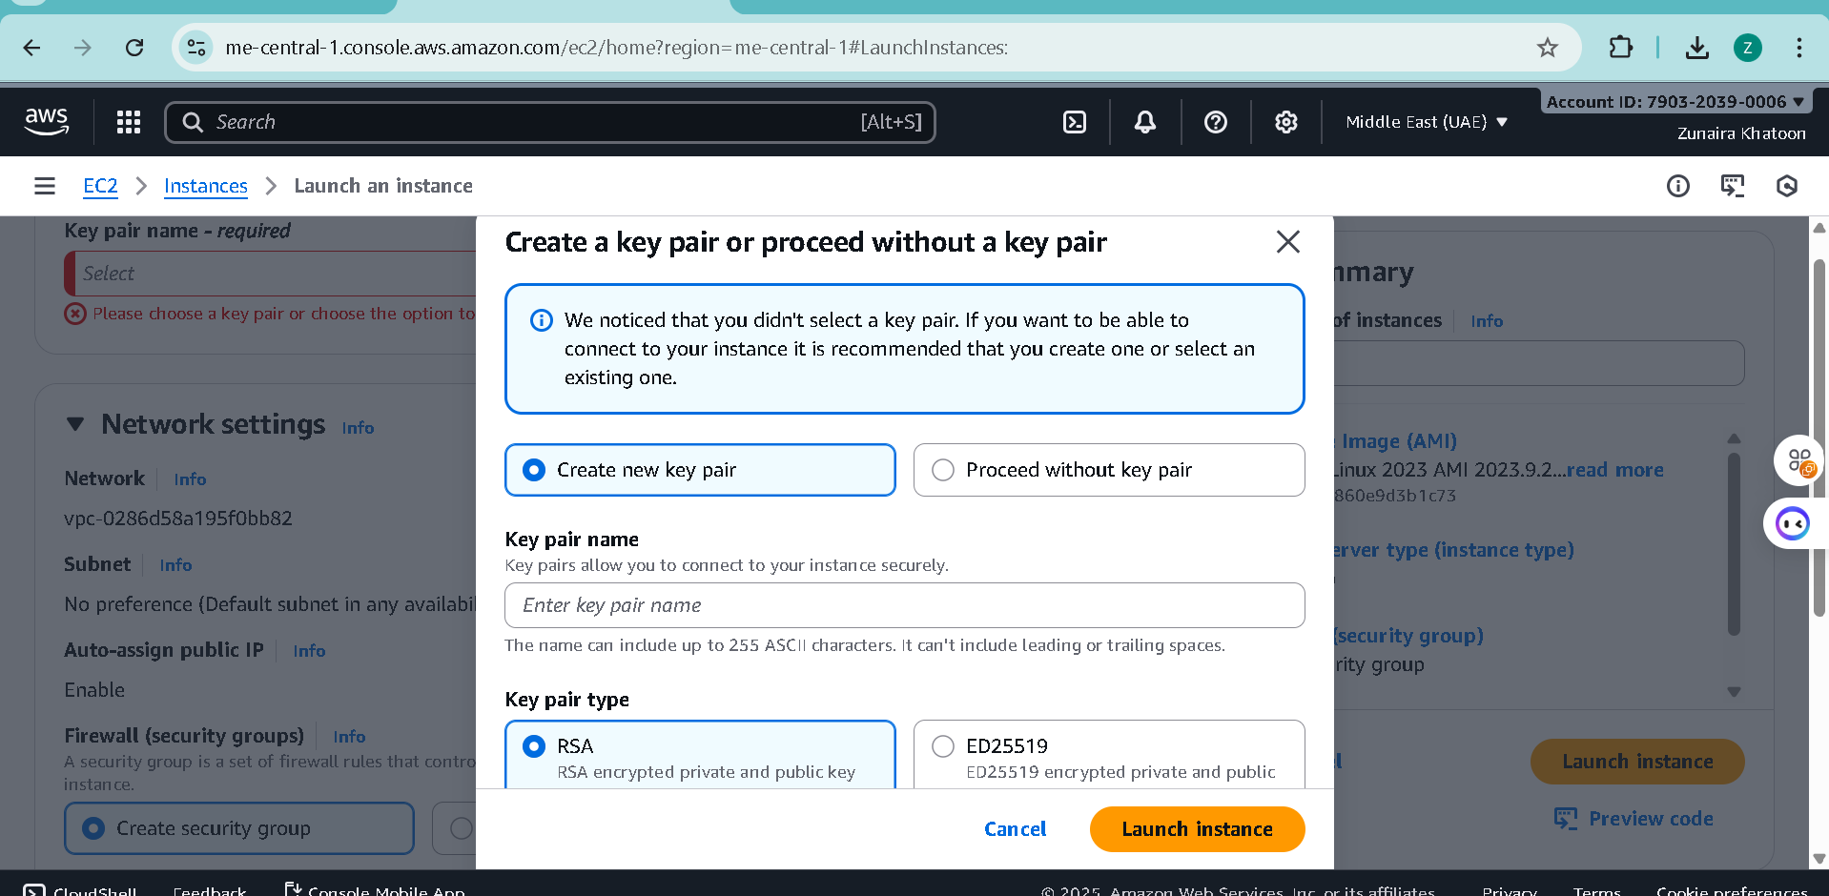

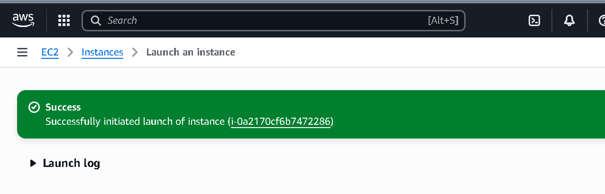

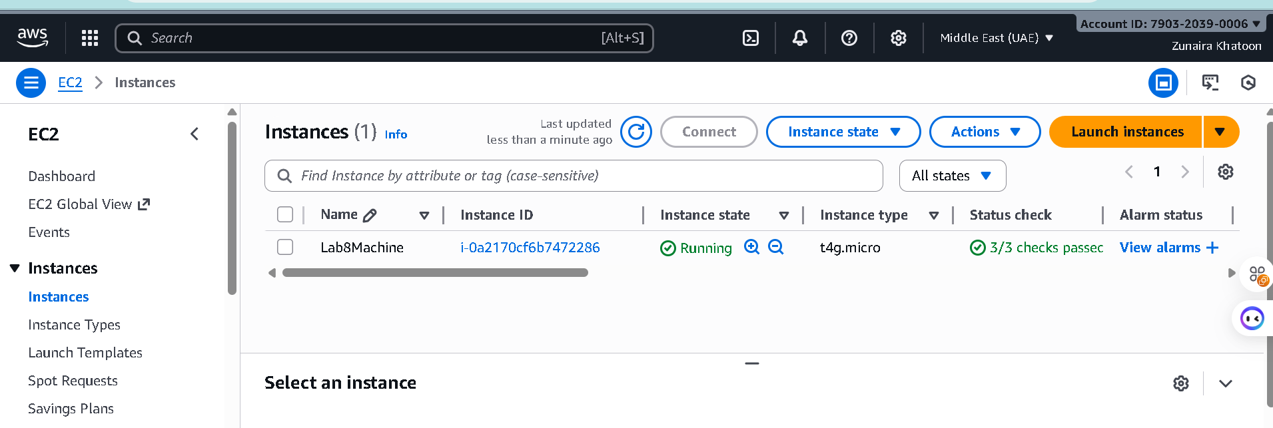

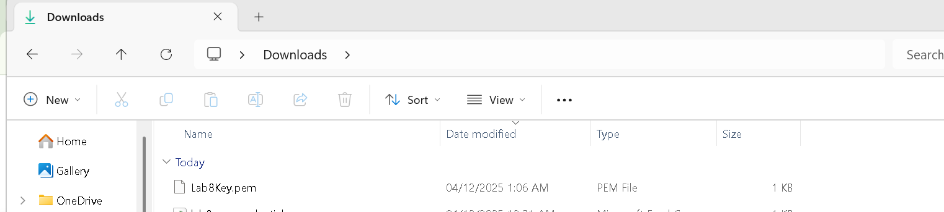

Step4: After launch, EC2 Instances list showing Lab8Machine in "running" state and public IPv4 visible.

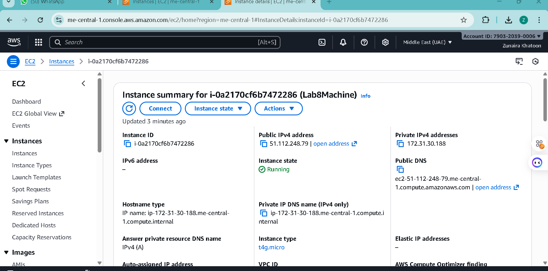

Step4: On Windows host, run SSH using the downloaded .pem (PowerShell/Git Bash/Windows Terminal):

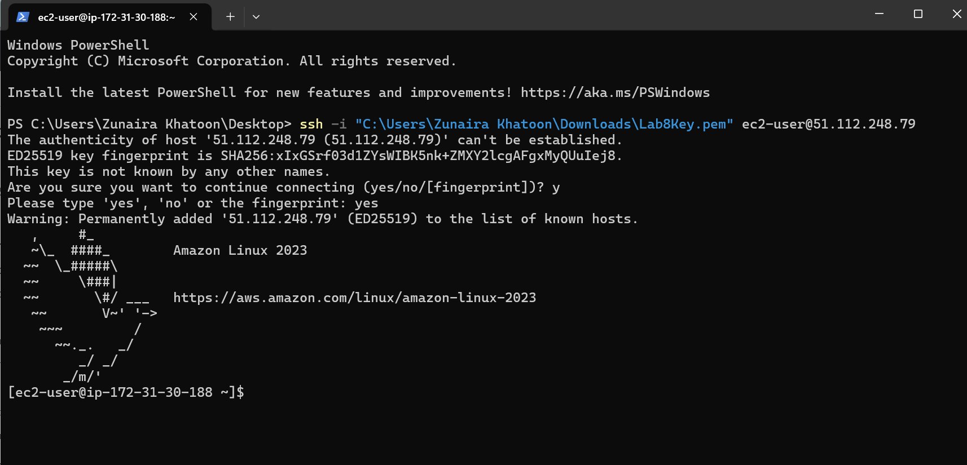

Step5: Run the install commands on the EC2 shell:

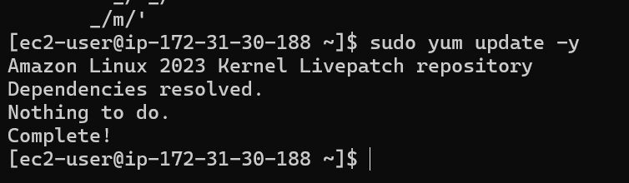

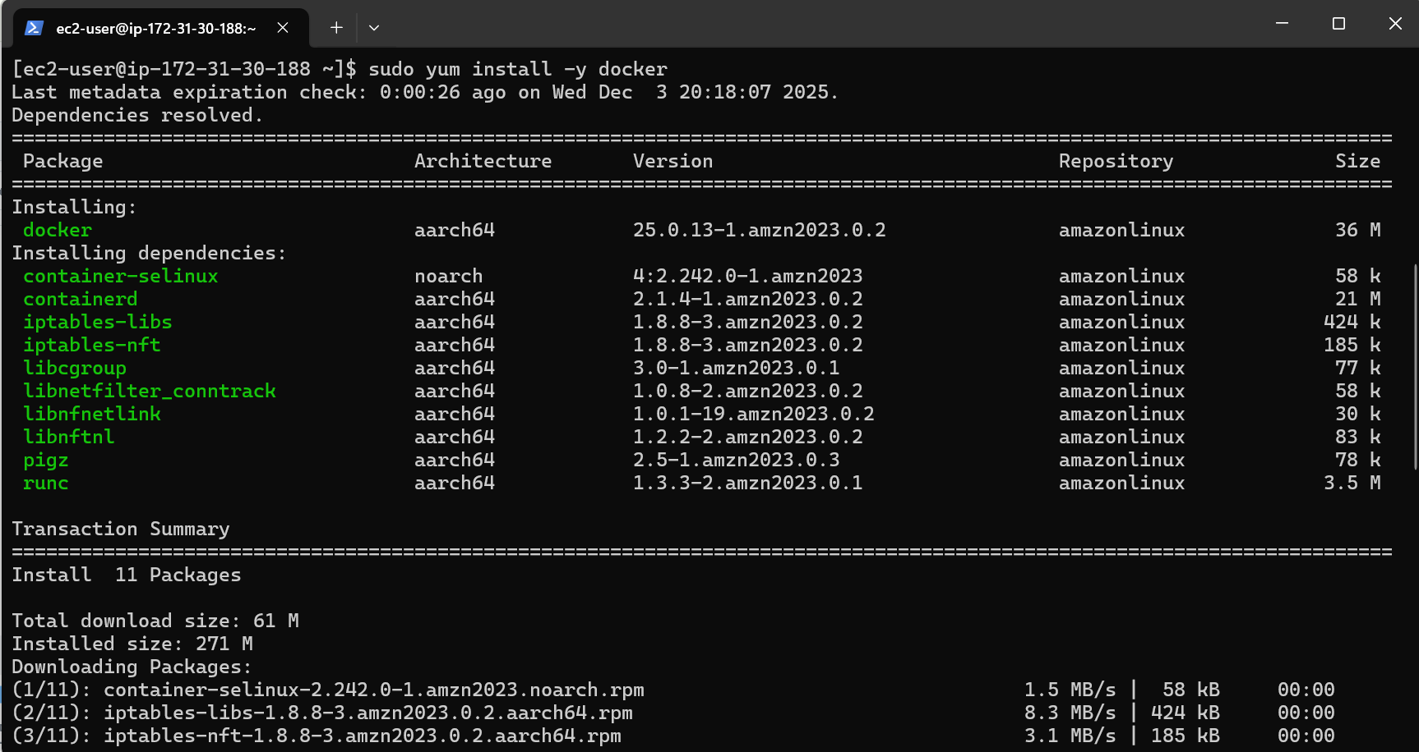

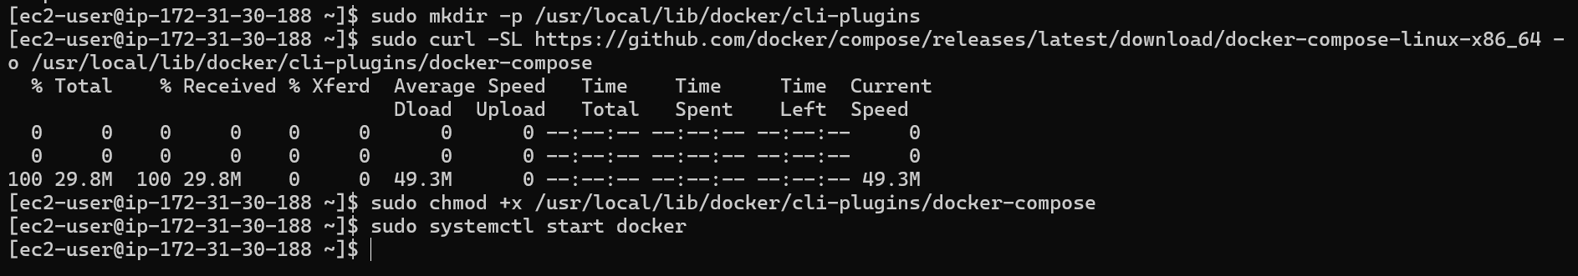

Step6: Create/edit compose.yaml on the EC2 instance (sudo vim compose.yaml) and paste content from the repo: [Gitea](https://github.com/WaqasSaleem97/Gitea) . While pasting, capture the editor content:

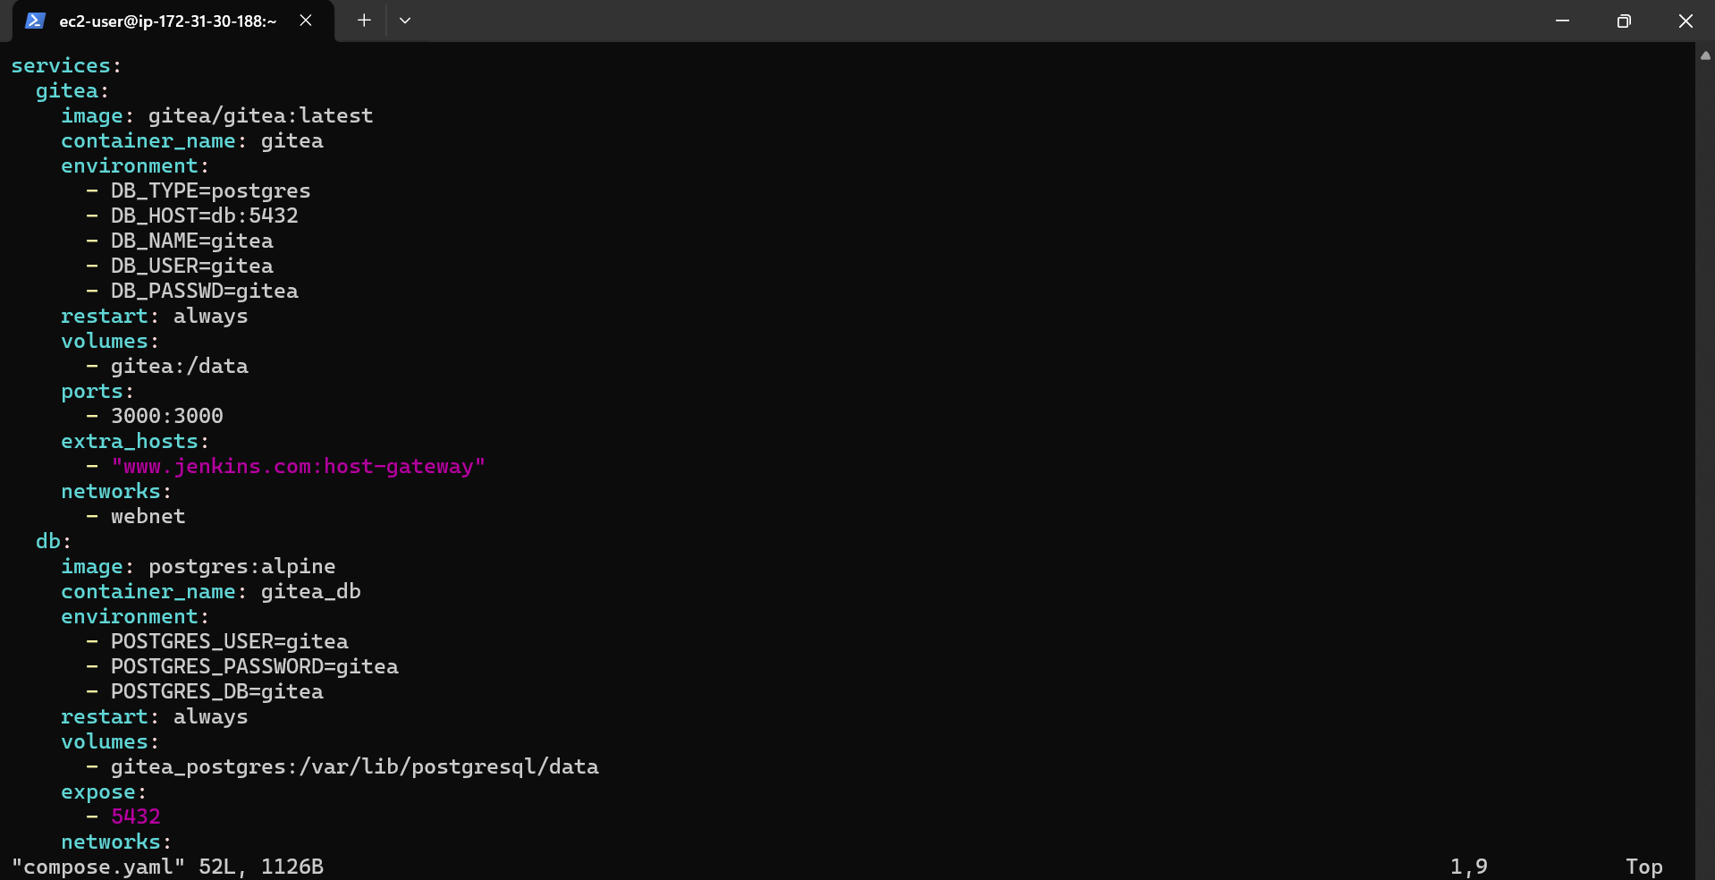

Step7: Save and verify file exists:

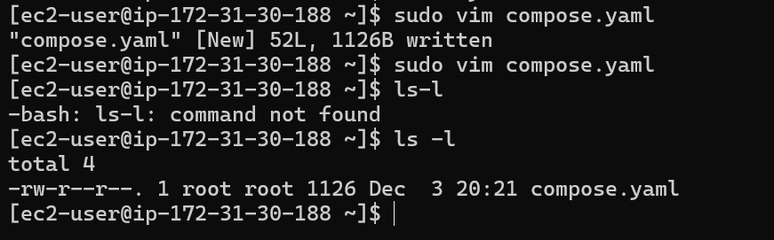

Step8: Add ec2-user to docker group, show groups before re-login, exit and reconnect, show groups after reconnect:

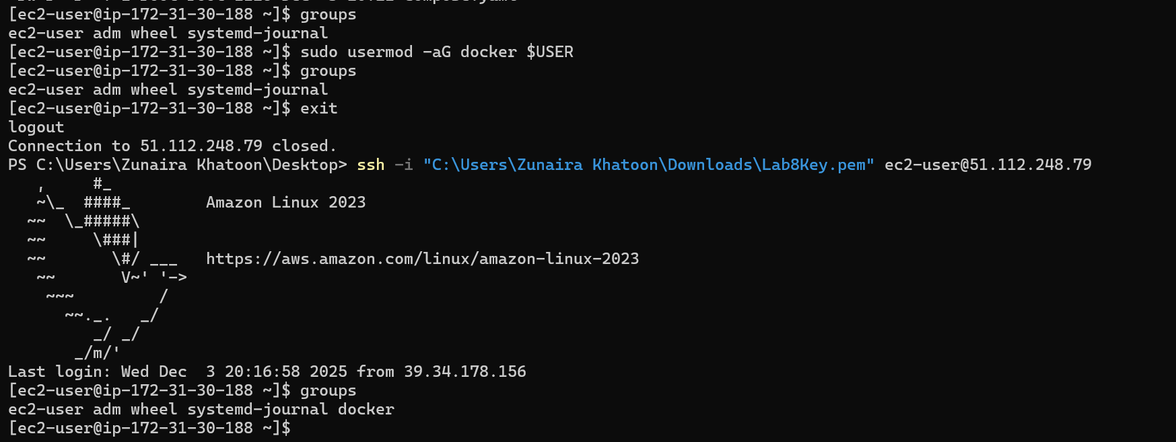

Step9: Run docker compose up -d from the directory with compose.yaml:

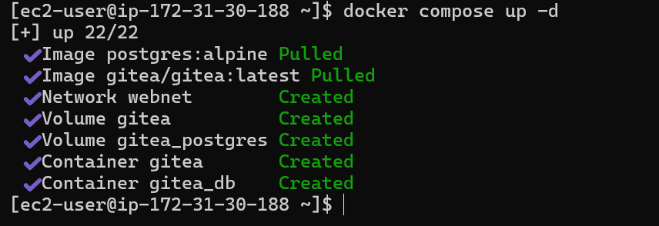

Step10: Edit the security group Lab8SecurityGroup inbound rules in the EC2 console: add Custom TCP rule port 3000 source 0.0.0.0/0 and save. Capture the inbound rules after saving:

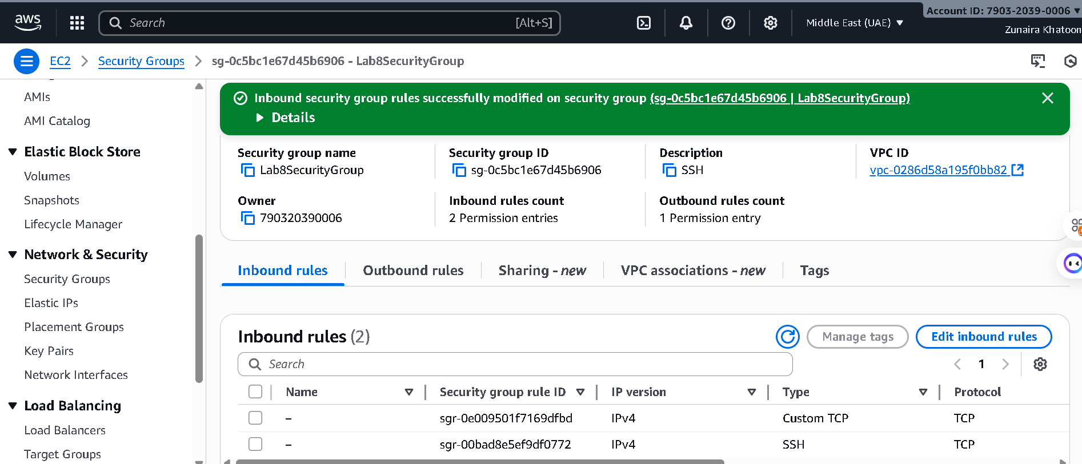

Step11:From your Windows browser navigate to: [http://Public-IP:3000](http://public-ip:3000/) — capture the Gitea setup/install page:

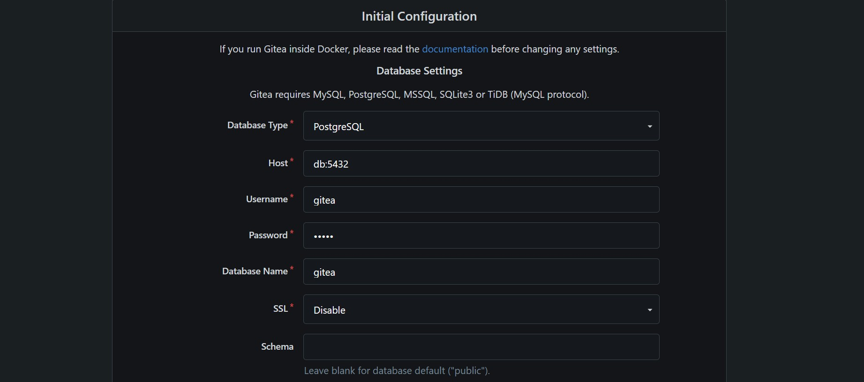

Step12: Complete initial Gitea setup (create admin user, create a repo) and capture Gitea showing the created repository:

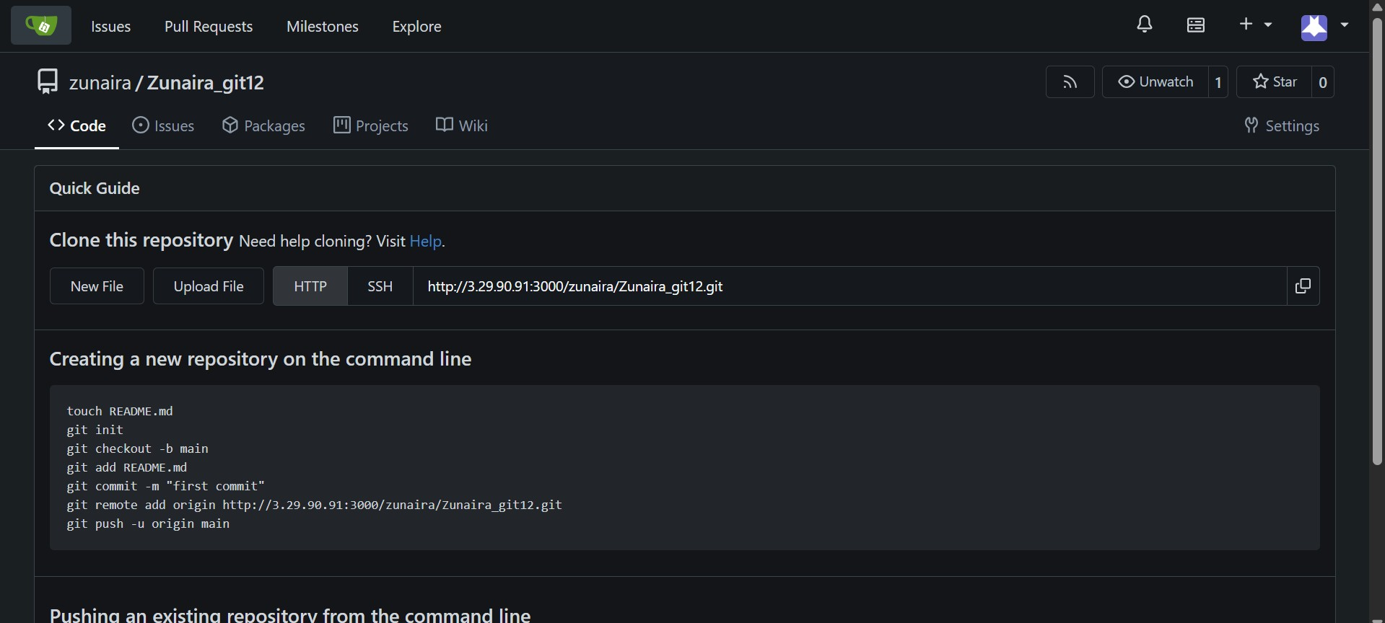

Step13: Task 4 summary (combine evidence)

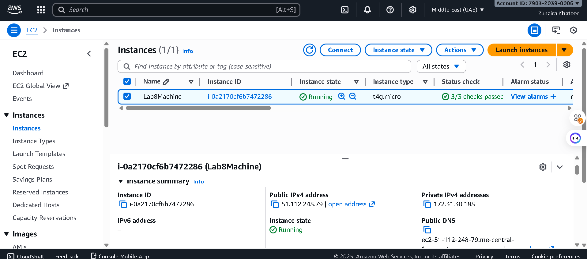

**Cleanup — Remove resources to avoid charges**

Step1: Terminate the EC2 instance Lab8Machine.

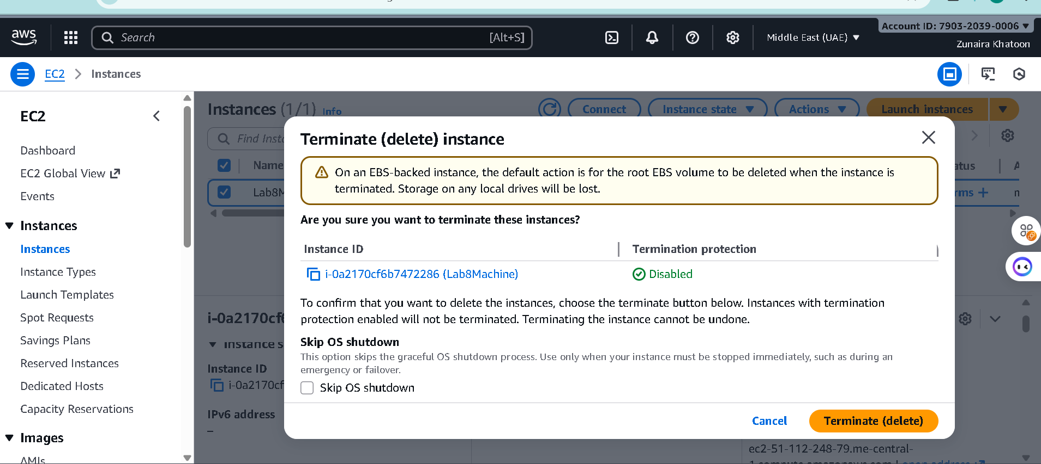

Step2: Delete associated EBS volumes and snapshots (if any).

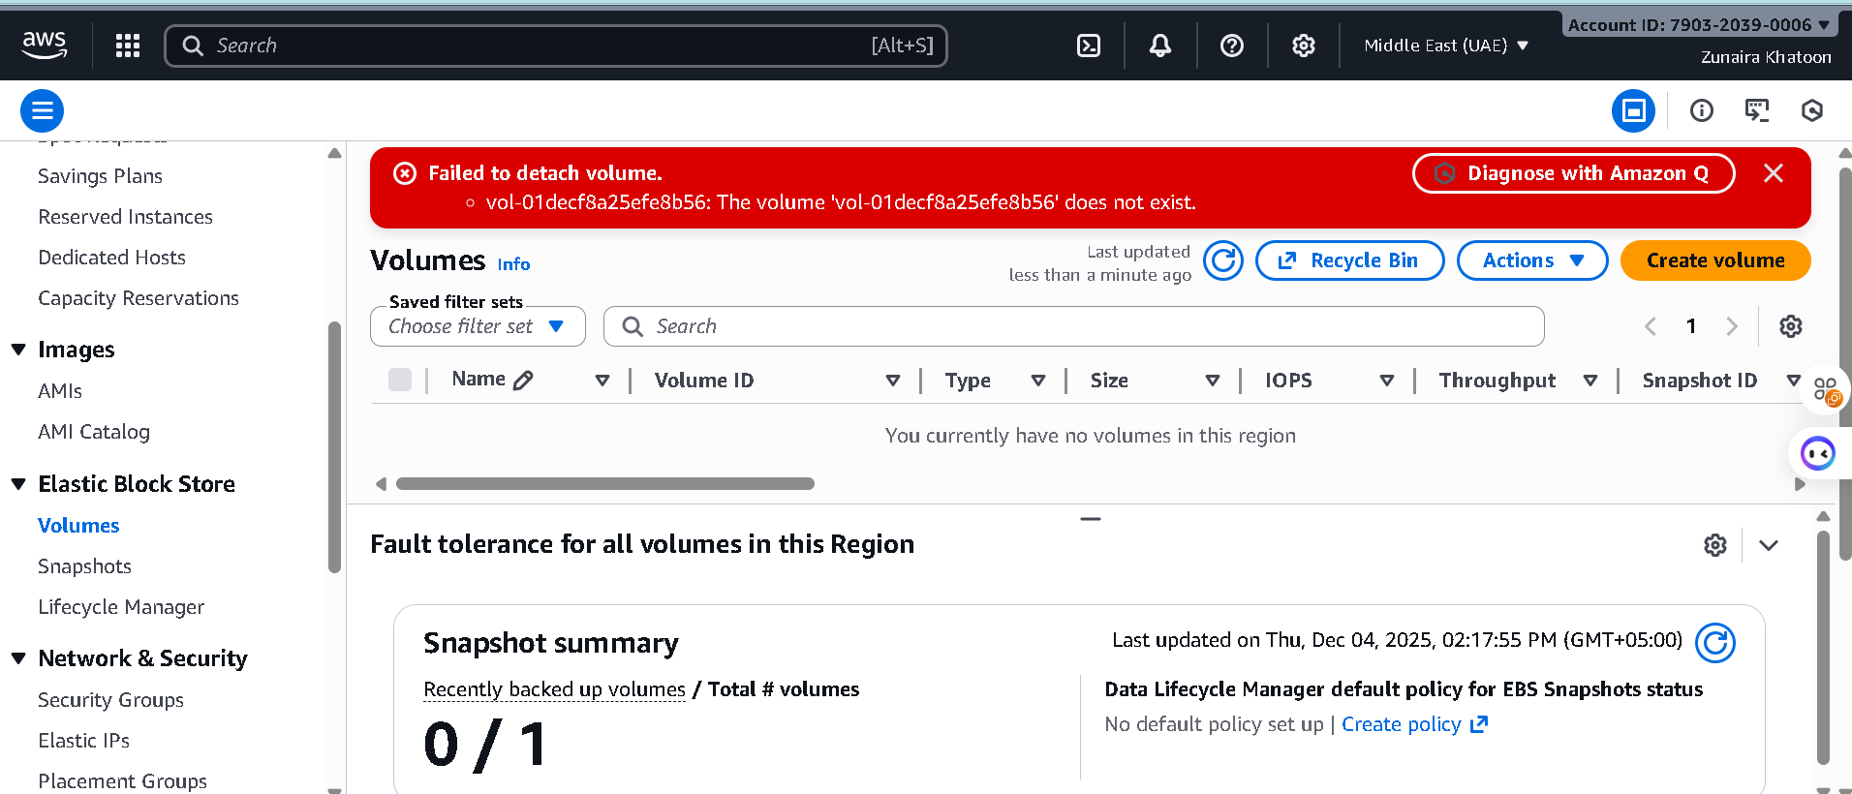

Step3: Delete security group Lab8SecurityGroup and key pair Lab8Key from the EC2 console (after instances terminated).

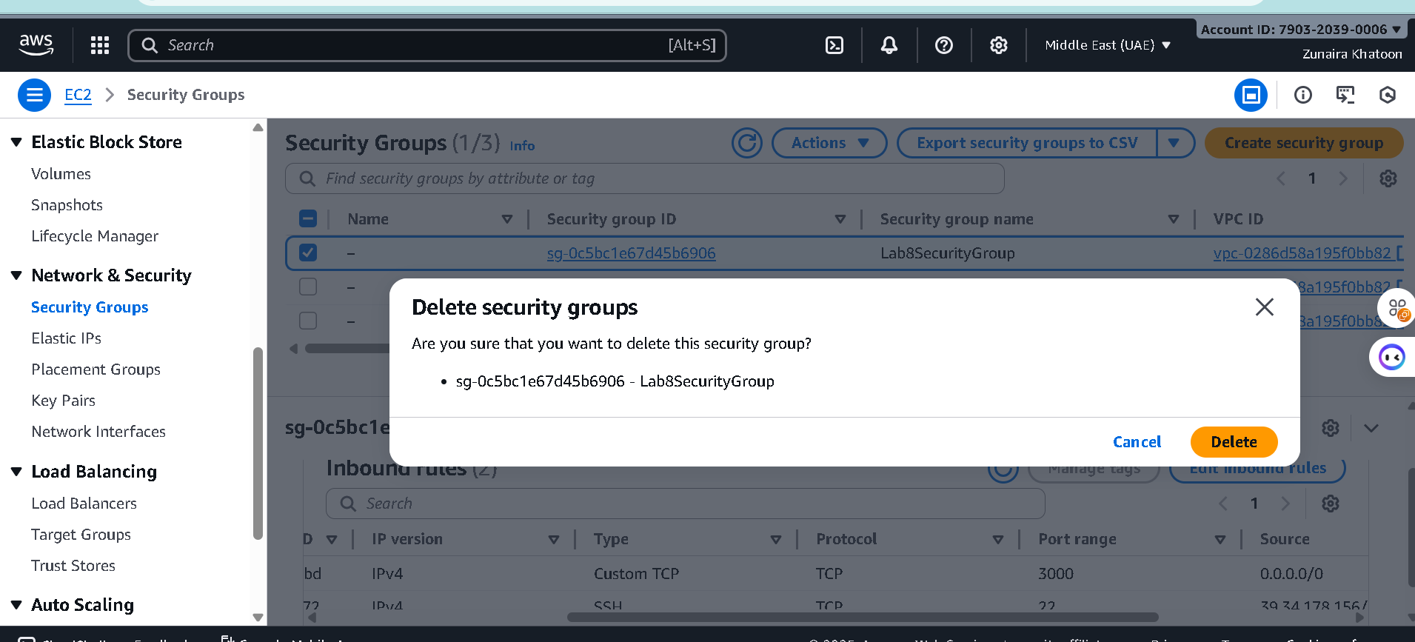

Step4: Delete IAM users Lab8User and any access keys.

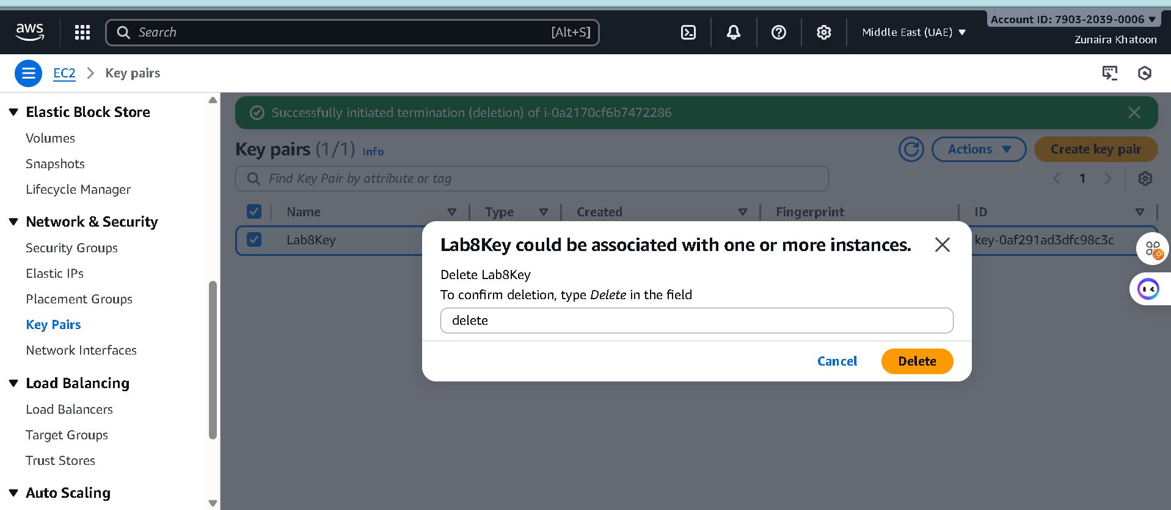

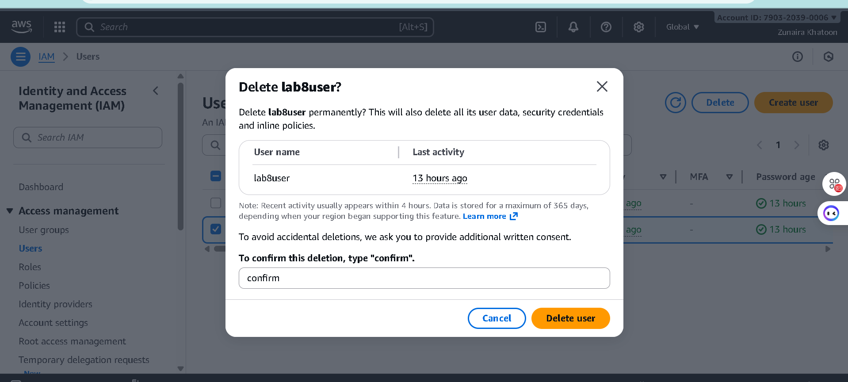

Final cleanup summary (show billing or resource groups with no active resources if possible).

